**Table of contents**

1. Attaching multiple files on Vendor Bills 03
2. Scheduled Email for PM for Pending Time tracks 06
3. Supplier auto subsidiary assignment option for vendors 08
4. Suitelet for Resource Allocation 16

# 1. Attaching multiple files on Vendor Bills

This section summarizes the setup of attaching multiple files on the vendor bill creation in Vendor center role. Vendor bills can be created in two ways; either by Submitting ( Creating a Vendor Bill Directly) or by Saving (Creating a custom record). User can attach maximum of 2 files per bills. They can update the files, then the previous files will be overwrite by new files.

This is a suitelet setup for creating and updating Vendor bills on Vendor Center role. You can go with the following navigation for that particular section **Transaction > Expense > Enter Vendor Bill.**

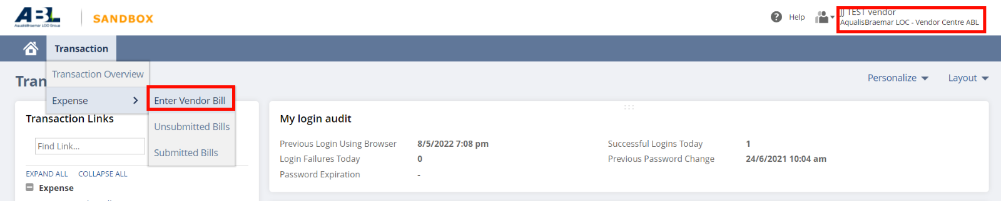

Vendor bills will be created for the logged-in vendor. The vendor could provide necessary details such as Reference Number, Project, etc. When the Project is selected all of its related details will be automatically populated on the page. After providing such details they could add the expense lines also.

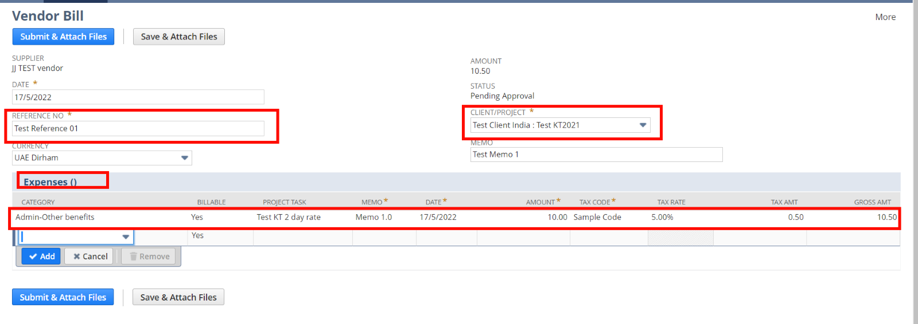  
When the first page is submitted, then the page for uploading files will be shown. Currently, the user can add a maximum of 2 files for a vendor bill. They could skip this section too. When the user clicks **Save & Attach files** button, that particular record will be saved as a custom record like a temporary saving. This will be listed on the **Unsubmitted Bills** section.

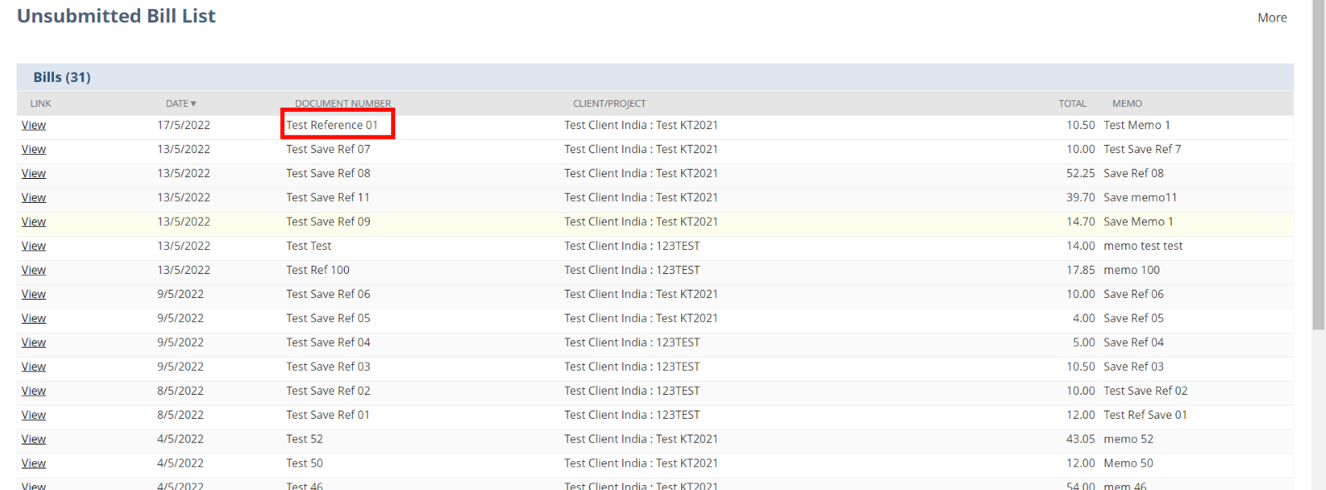  
The user can edit these bills and change the files attached to it or they can remove the files if they want.

If the user clicks on ‘**Submit & Attach Files**’ button, then this vendor bill will be saved as standard Vendor bill record. When this record will be in **Pending Approval** status, this can’t be edited from the Vendor center role.

**Removing Attachments**

1. Open any submitted/ Unsubmitted Bill which has/has not any attachments

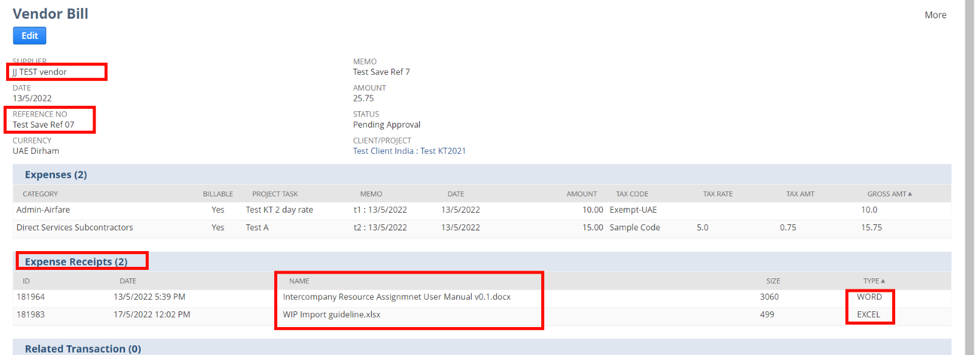

1. Edit the bill and Update the first page, if you want. Then click ‘**Save /Submit & Update Expense Receipt**’

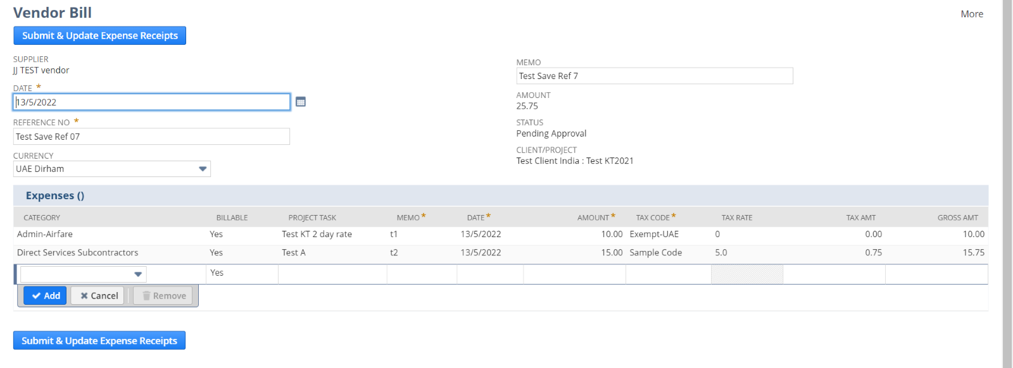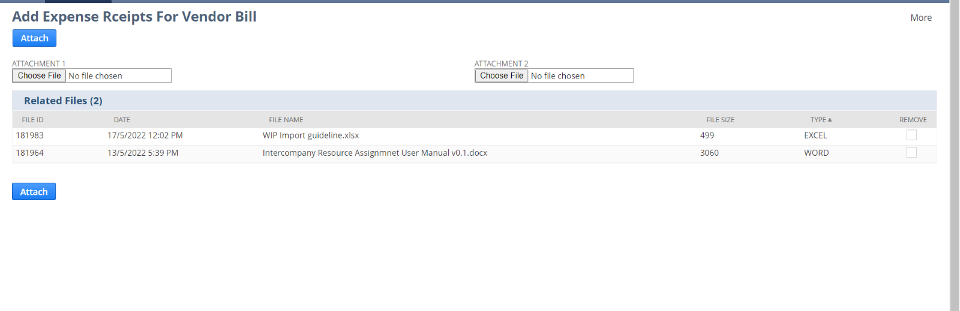

1. In the sub list, You can see a checkbox named ‘**Remove**’. You can check the attachment you want to remove and click **Attach**

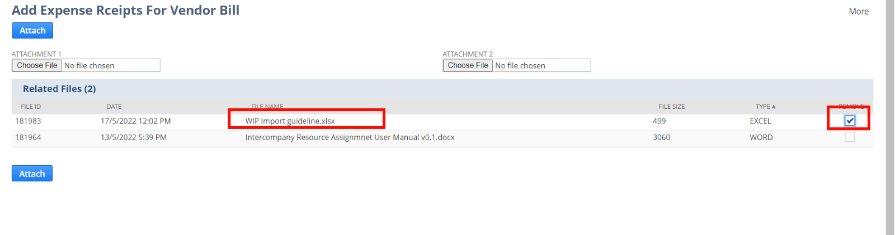

1. Open the same bill, which you’ve edited you can see the changes in the Expense receipts sub list

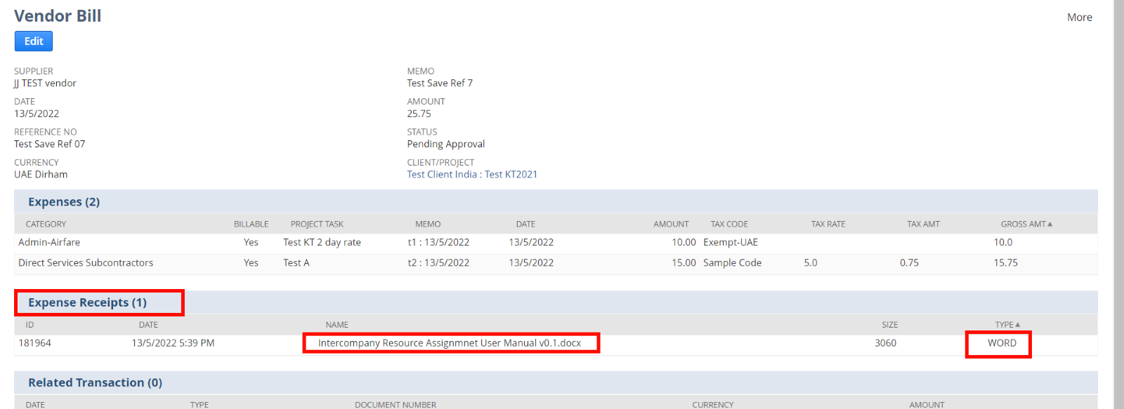

2. Scheduled Email For PM for Pending Time tracks

This section summarizes the setup of scheduling Emails for Project Managers regarding each one’s Pending Time track. Its Schedules at the end of the day and It contains details of each pending time track records. The PM can approve each time track from the mail.

Navigation and the steps for the execution is listed below.

1. Customization > Scripting > Scripts

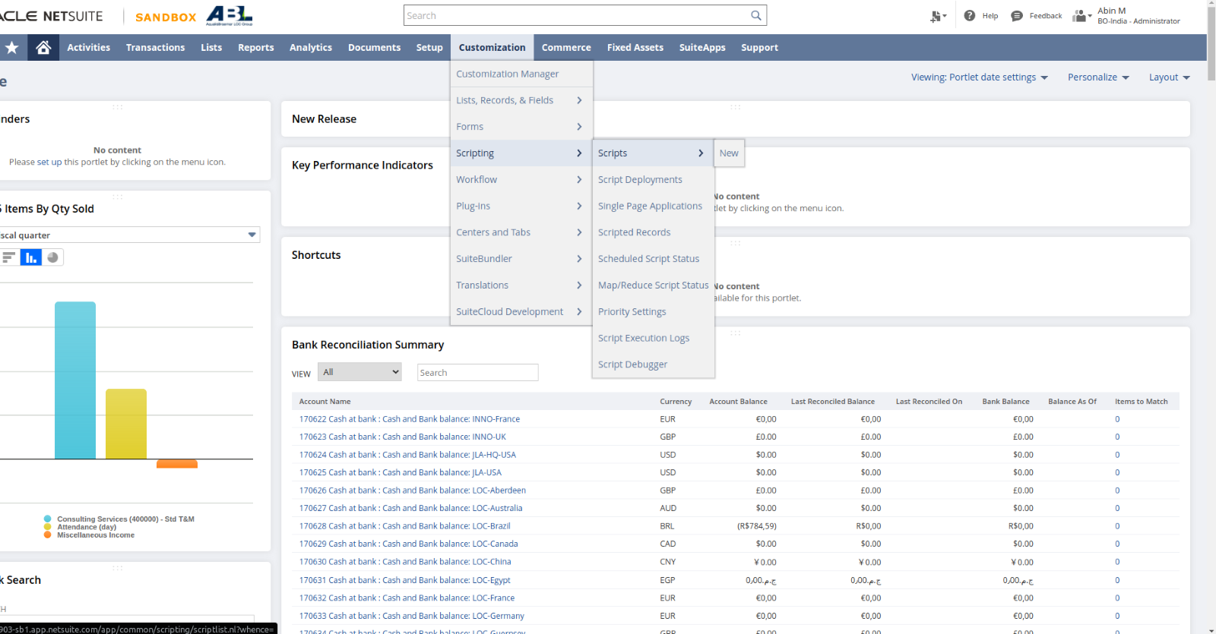

1. Open the script **‘JJ MR Scheduled Email for PM AQ-3416’**

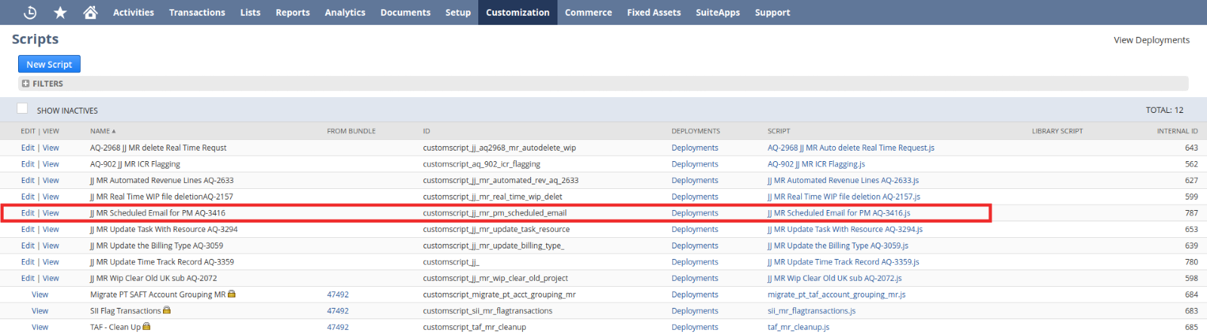

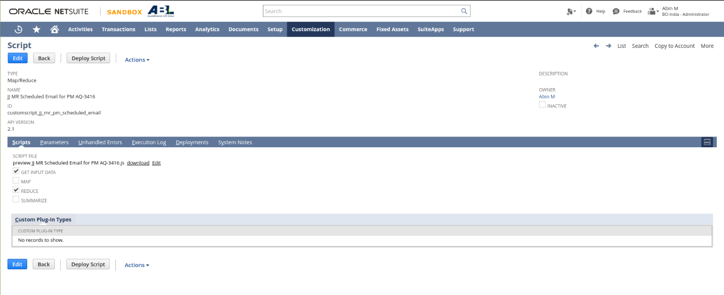

1. Click Edit, then Save and Execute

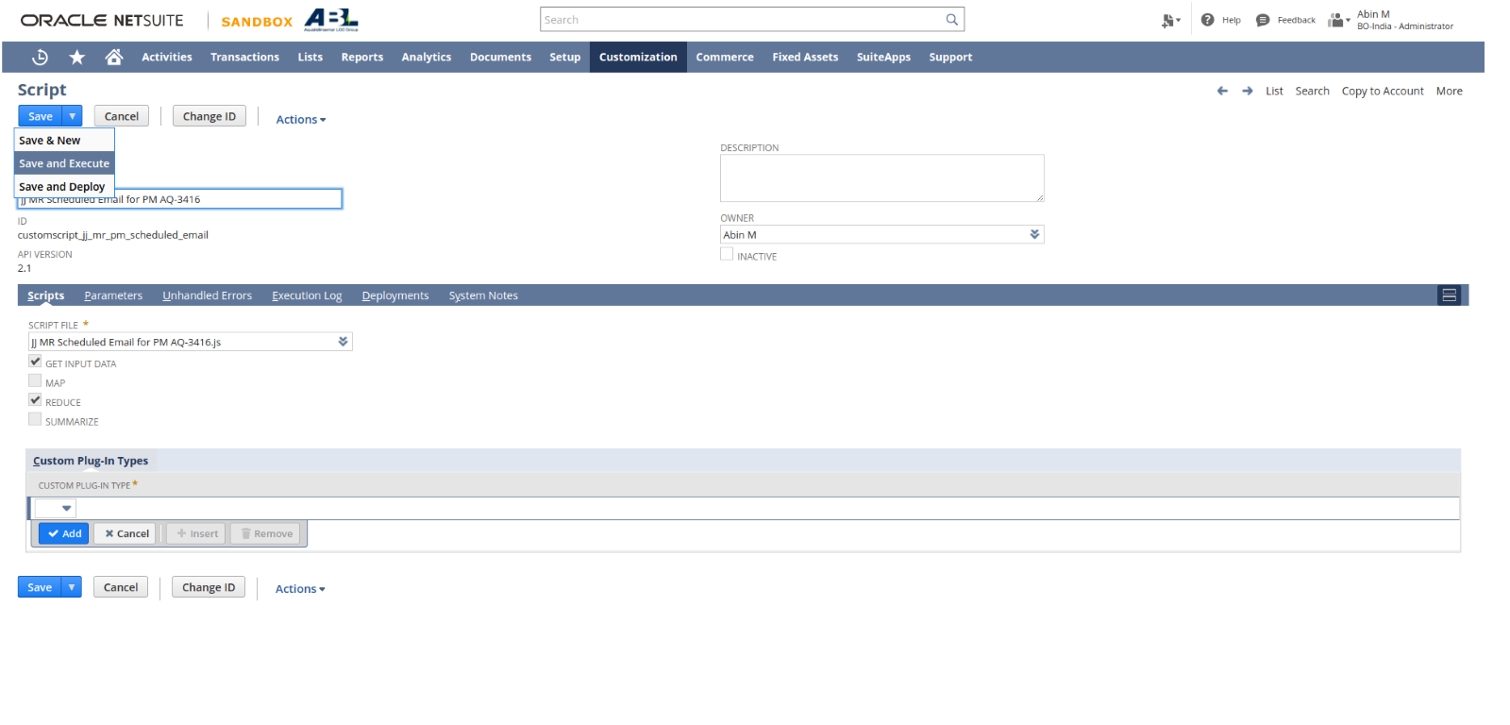

1. Click refresh until the status becomes Completed.

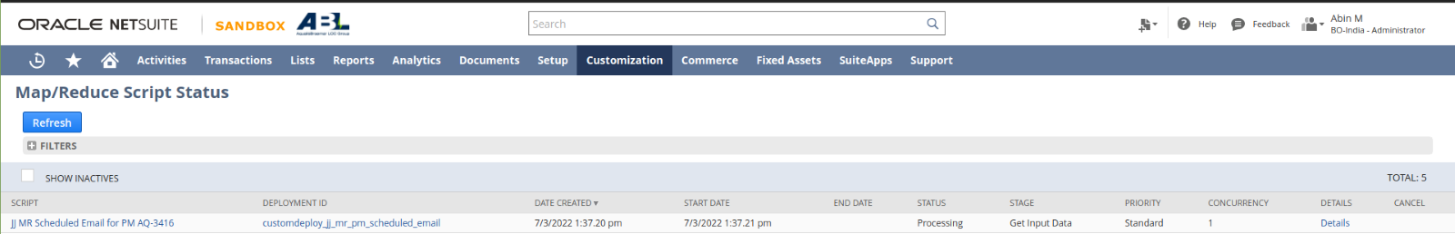

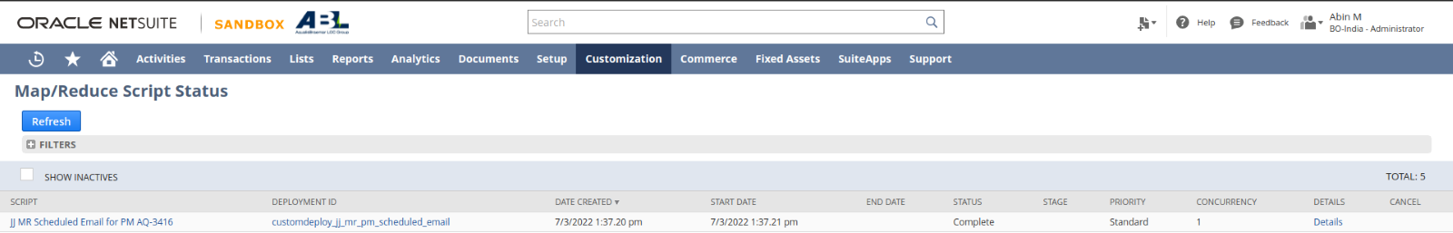

1. Sample of Email Content

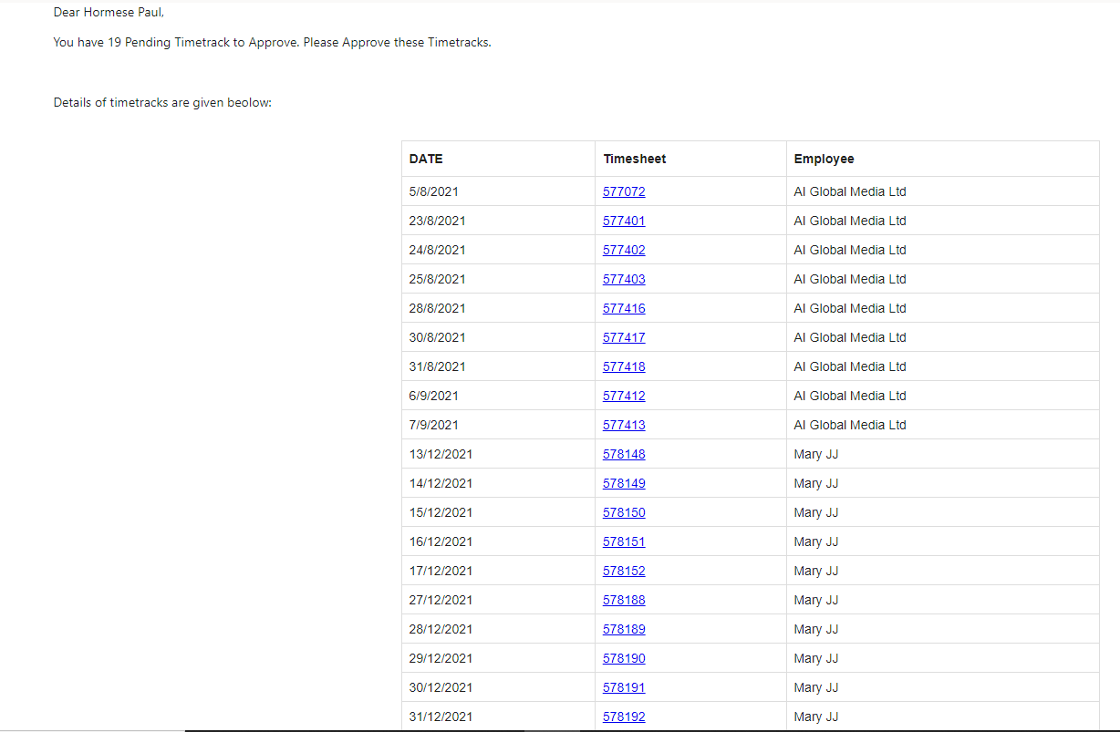

3. Supplier auto subsidiary assignment option for vendors

This section summarizes the setup of automatically assigning subsidiaries and currencies for intercompany vendors/ suppliers. For this, there is a custom check box for making suppliers intercompany resources or not. If the checkbox is checked, and upon saving the record, all the other subsidiaries (some exceptions) and currencies will be automatically assign to the supplier.

Following is the steps for executing the section on both create and edit mode.

**Create Mode**

1. Create a new Supplier by List > Relationships > Suppliers > New

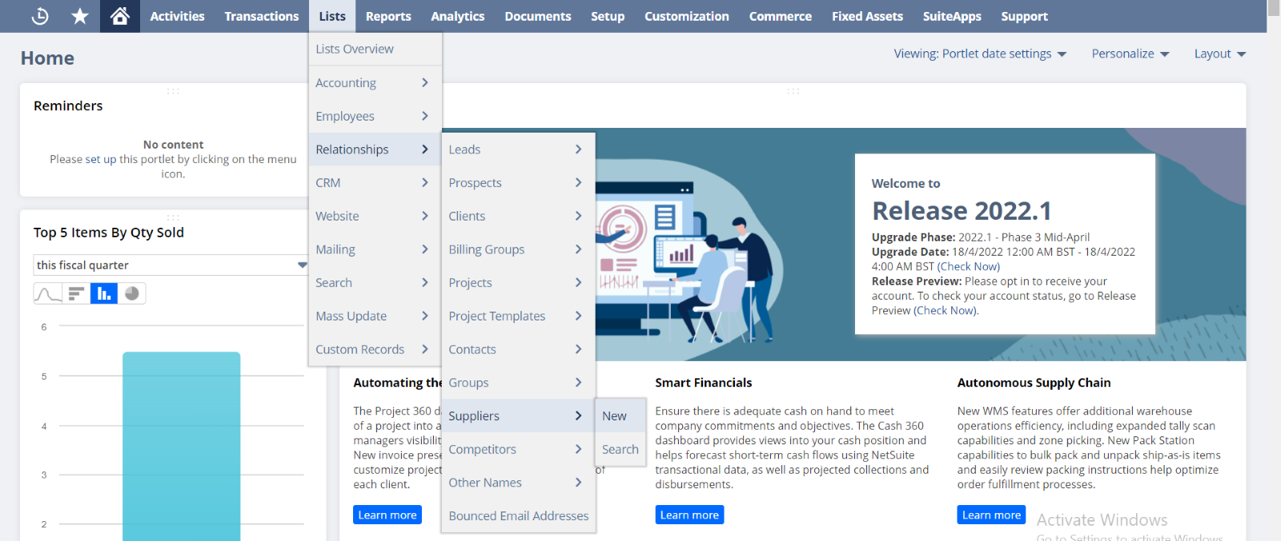

1. Add details of the vendor

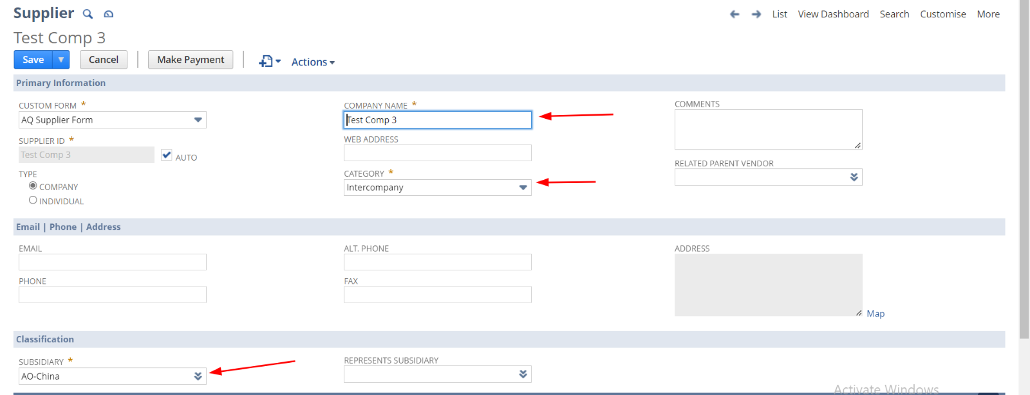

1. Provide **Represents Subsidiary**

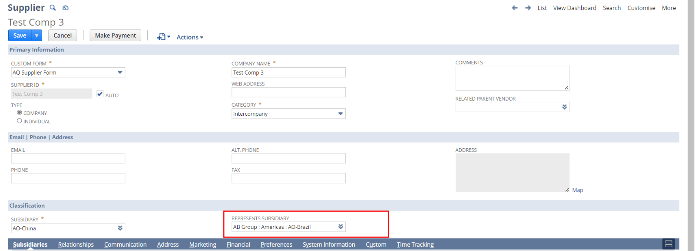

1. Uncheck the **Project Resource**  check box

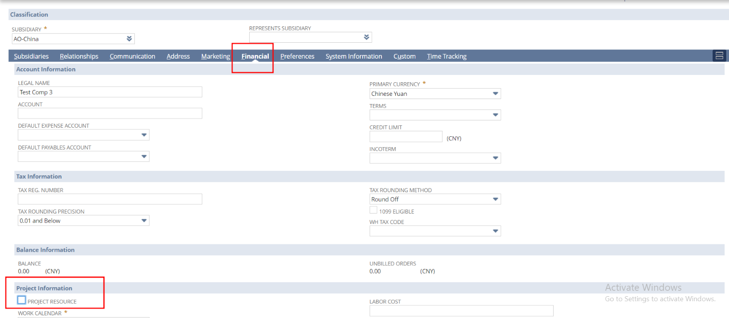

1. Check the **INTERCOMPANY CLIENT/VENDOR** checkbox

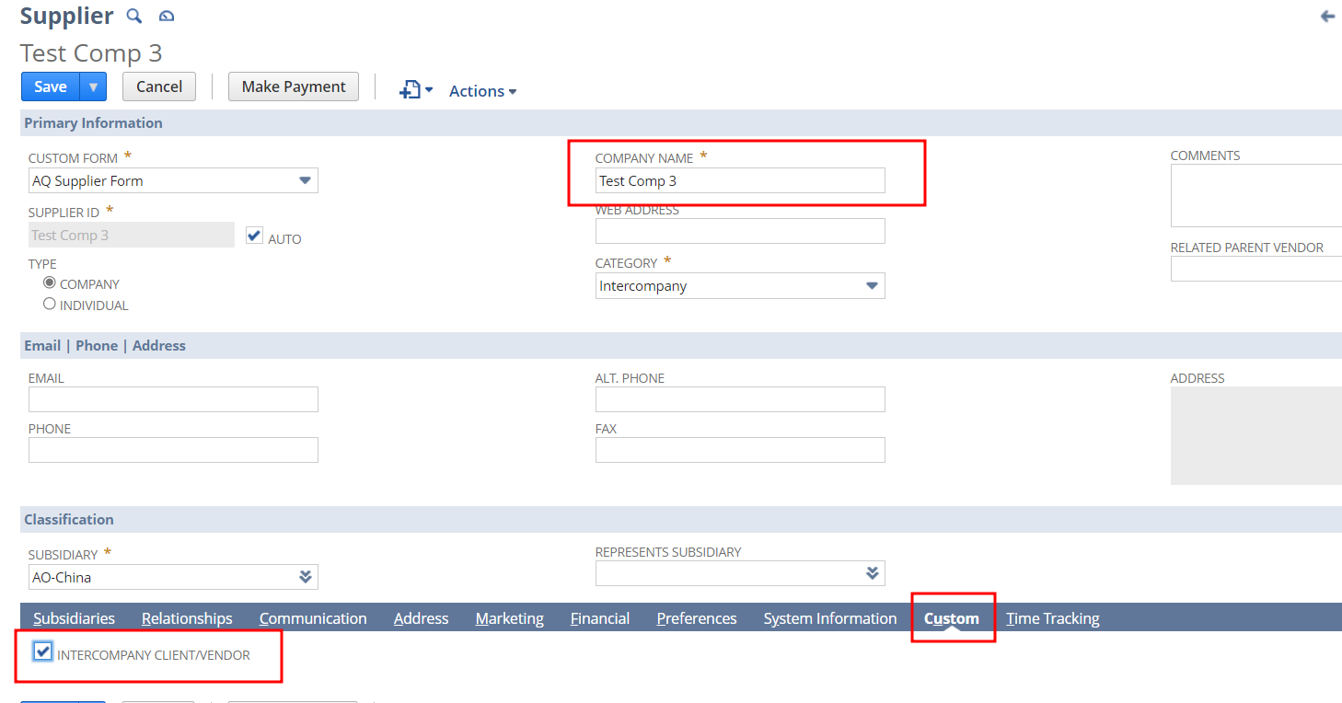

6. Click Save and refresh the Page

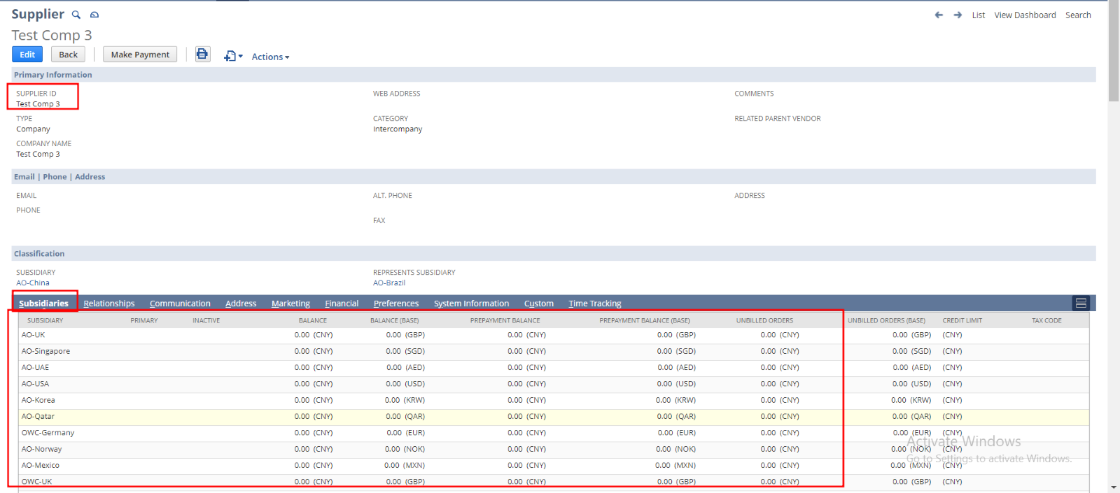

Check on Currencies sub tab Financial sub list

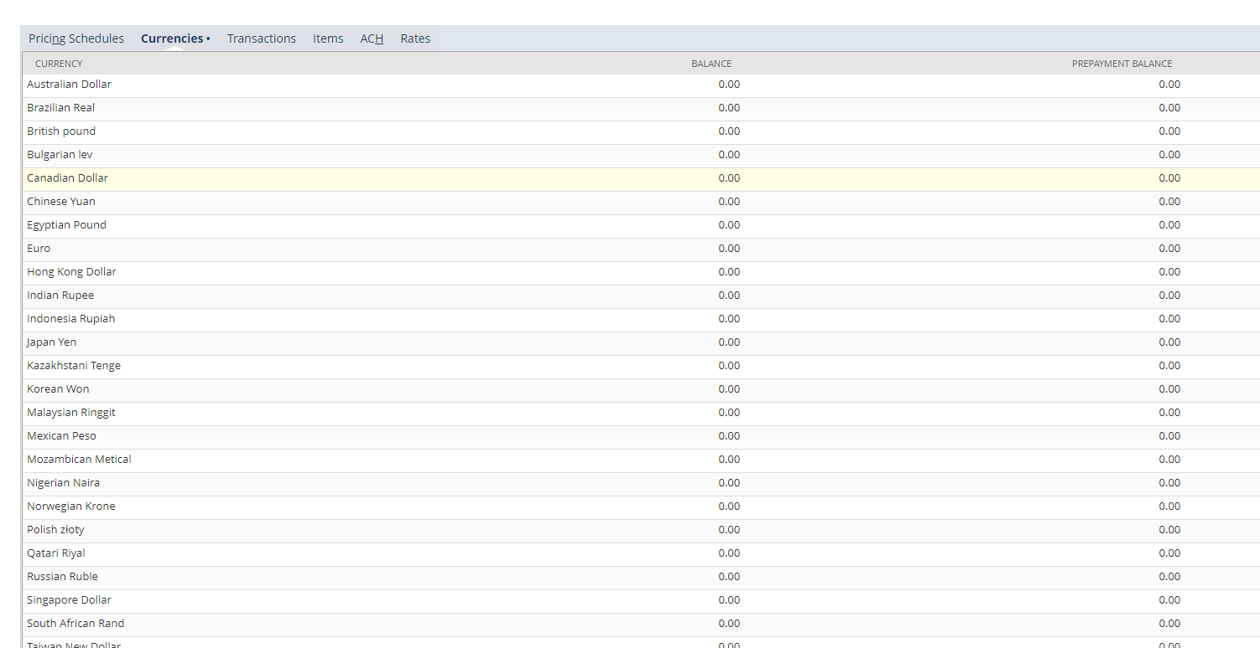

**Edit Mode**

1. Create a Vendor through the Navigation List > Relationships > Suppliers > New



1. Add details

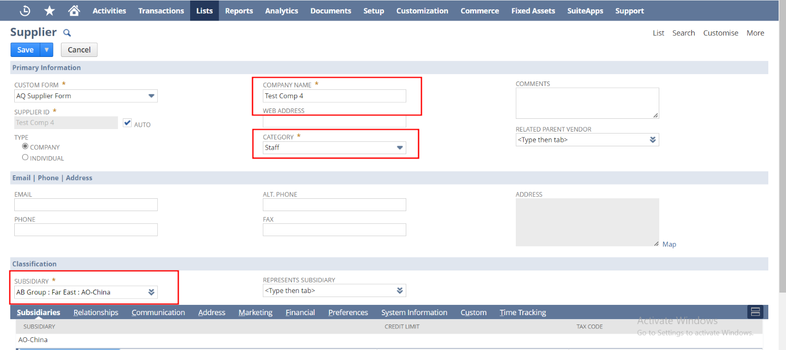

1. Leave the **Represents Subsidiary** blank

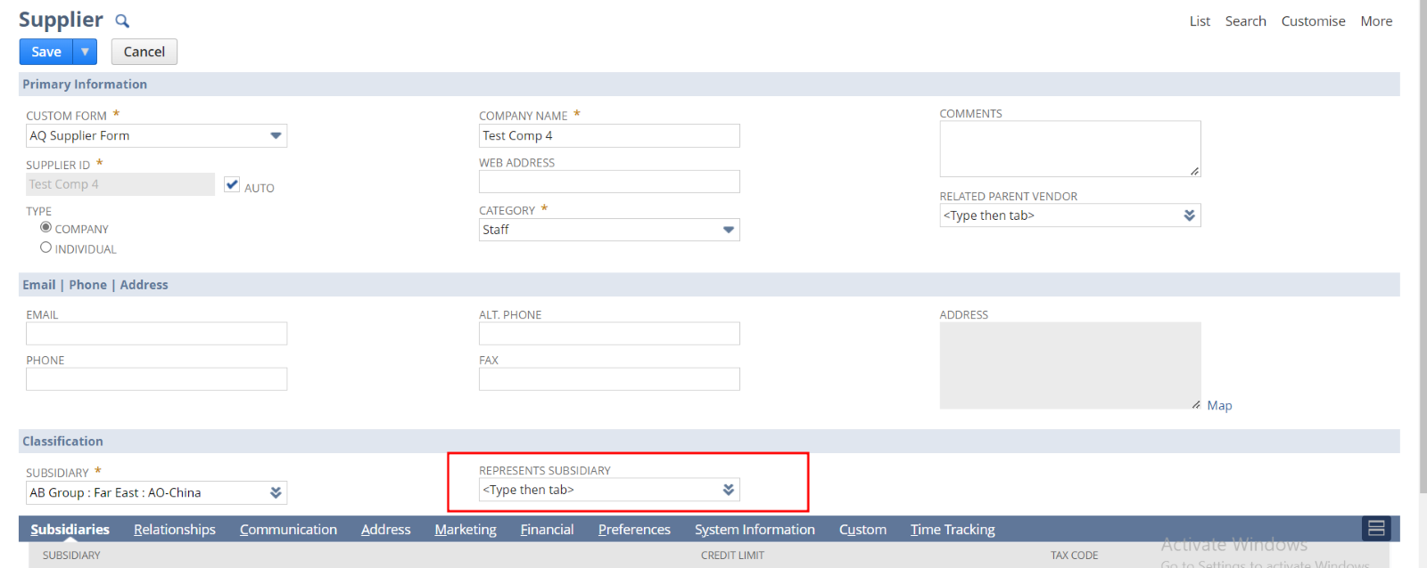

1. Check the **Project Resource**  check box

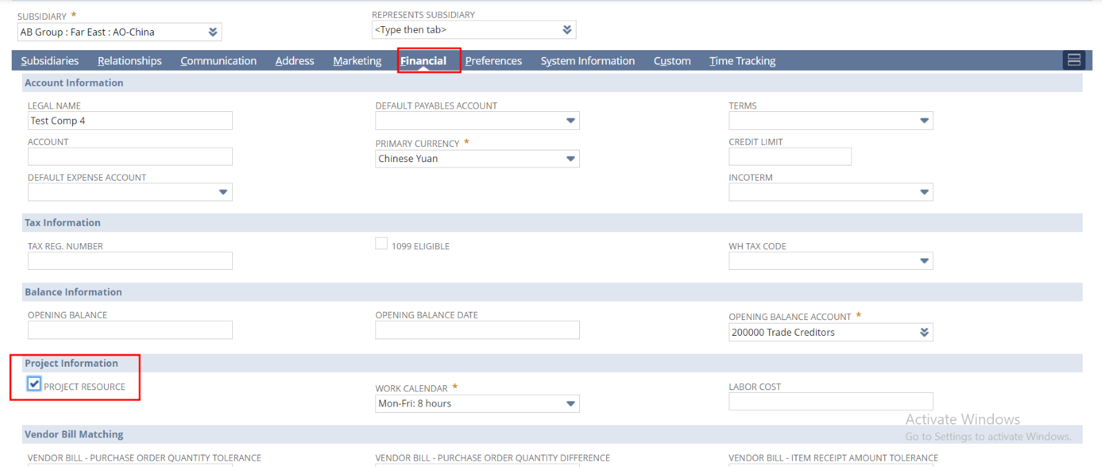

1. Click Save ( **INTERCOMPANY CLIENT/VENDOR** checkbox will be unchecked)

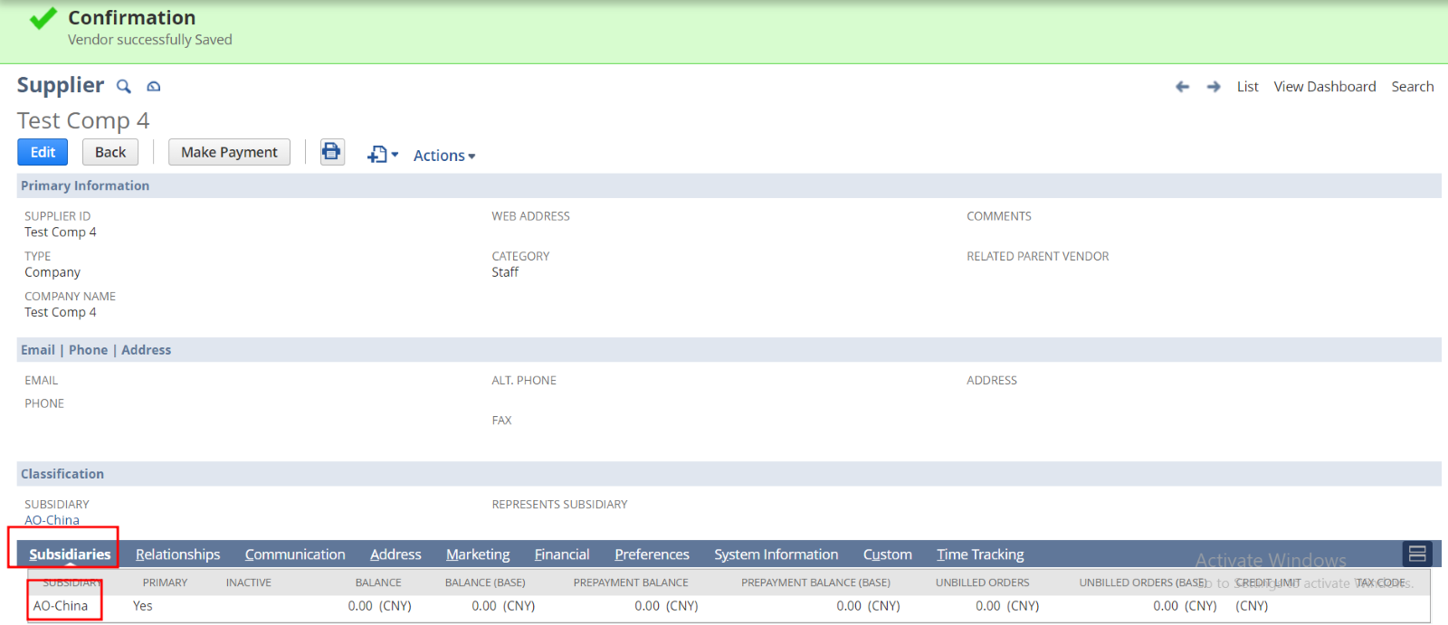

In the Financial sub list

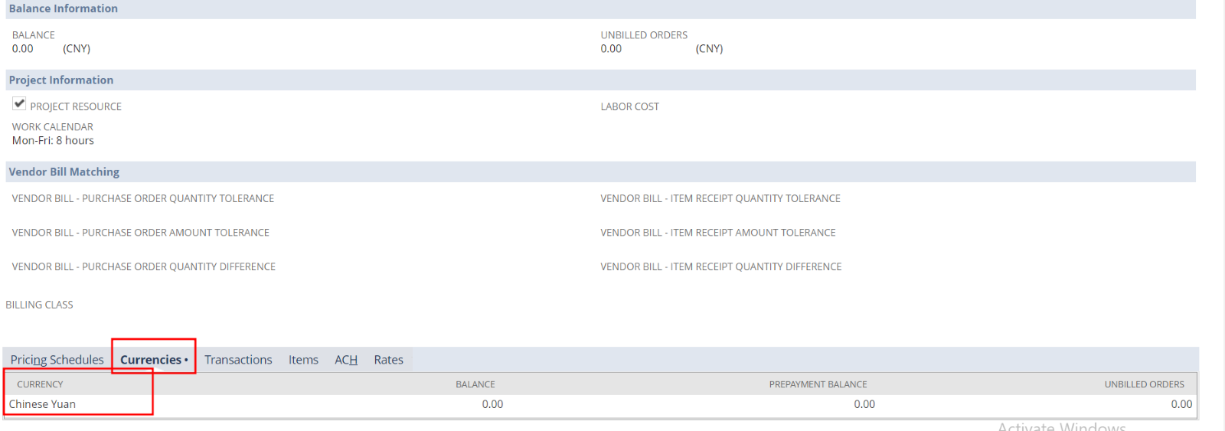

1. Click Edit
2. Provide **Represents Subsidiary,** uncheck **Project Resource**  check box and check the **INTERCOMPANY CLIENT/VENDOR** checkbox

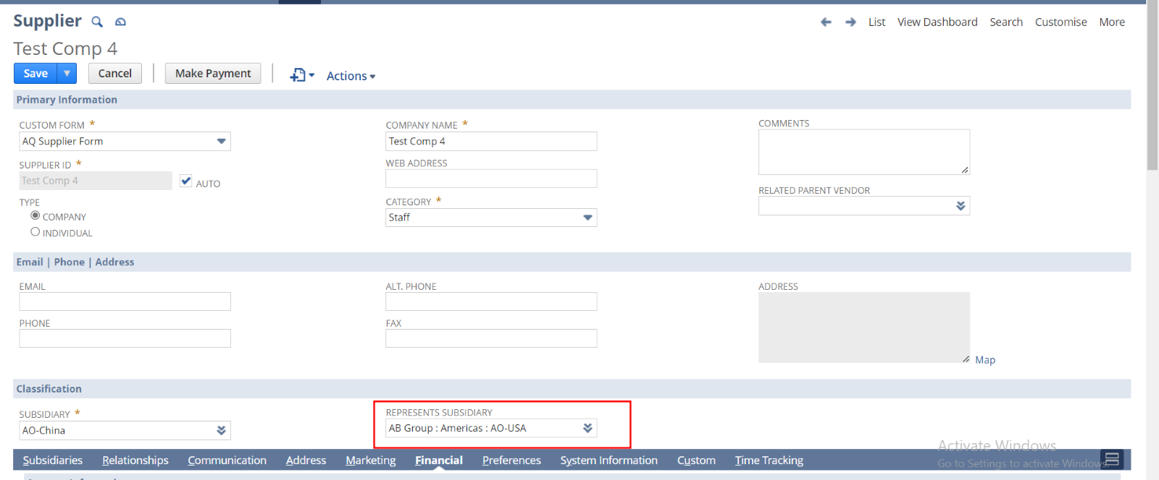

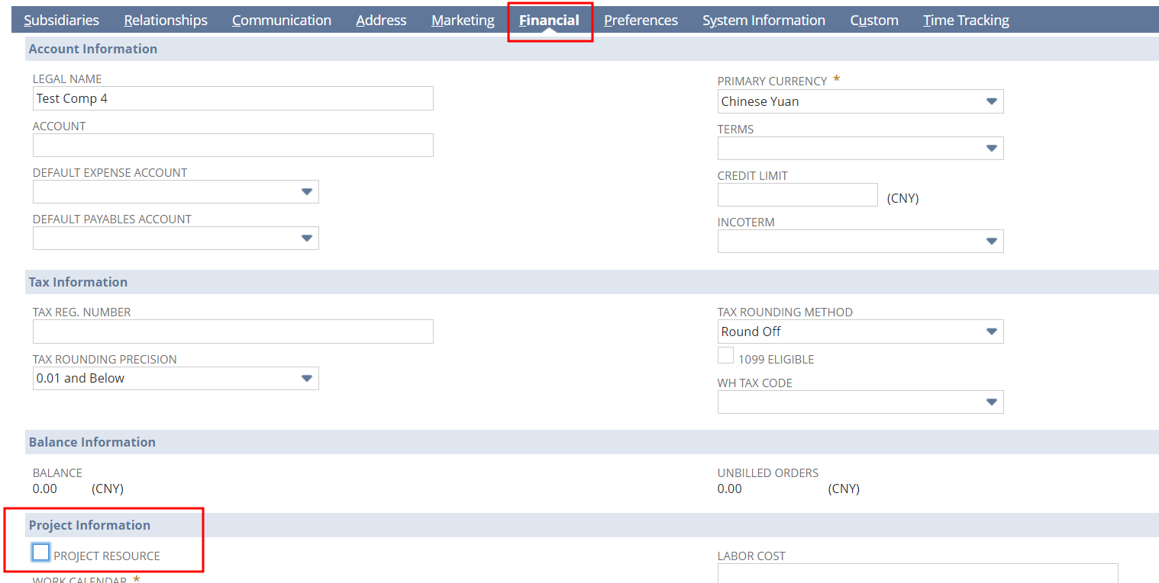

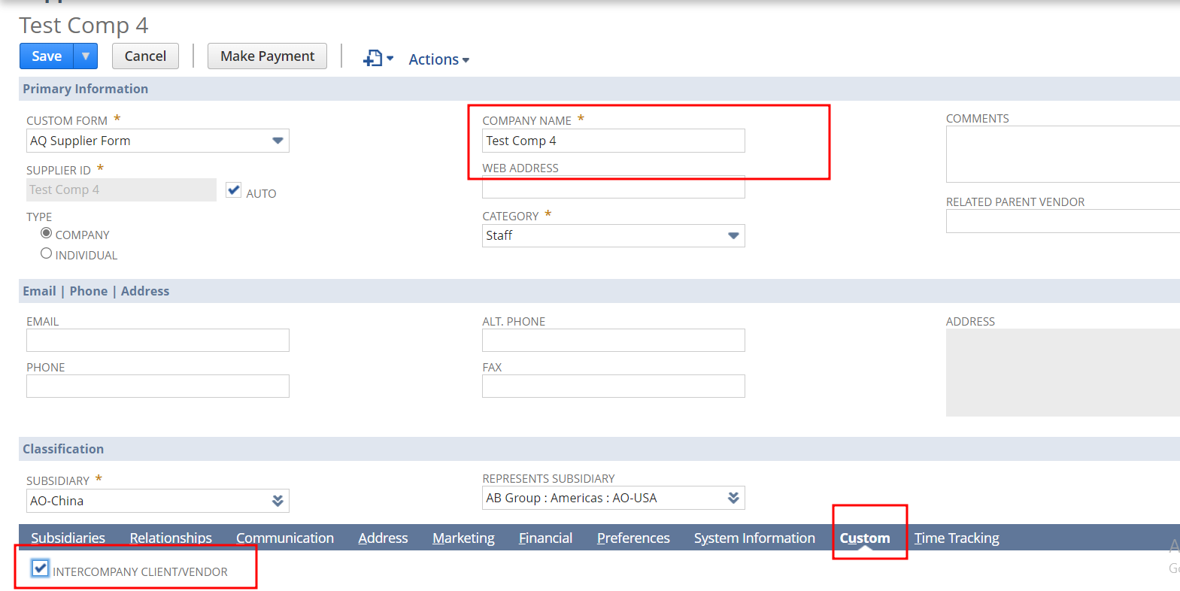

1. Click save and refresh the page

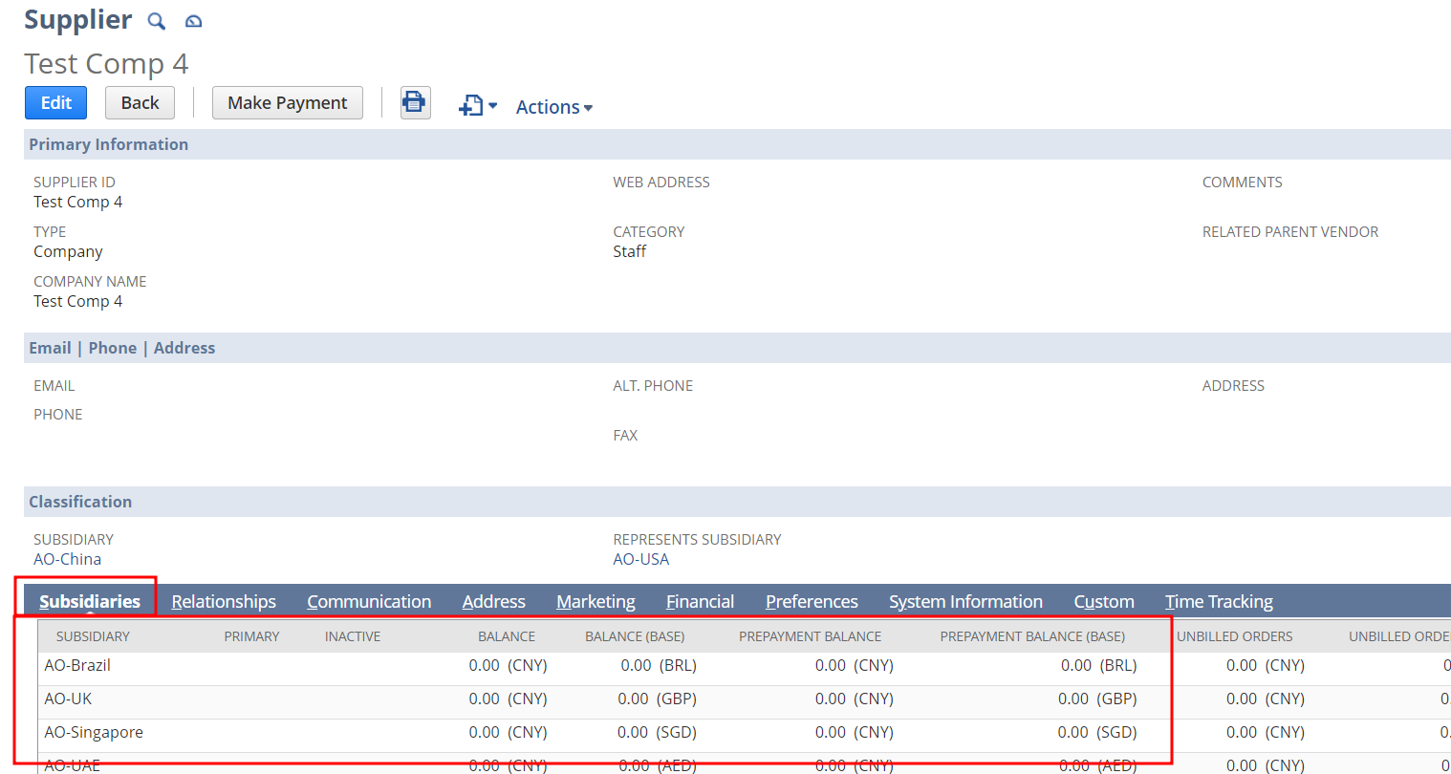

**Currencies** from **Financial** Sub list

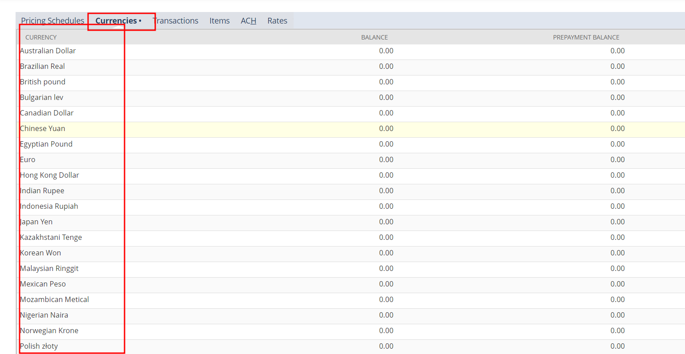

4. Suitelet for Resource Allocation

This document summarizes the setup of allocating generic resources, employees and vendors to a project task through a suitelet. User can allocate a task by selecting its respective project and user can also decide whether to add vendors of the same subsidiary and billing class, or not. When the task is allocated to resources those resources will also added to the project record also. This process is available on Administrator, Employee center and financial center roles.

**Navigations**

|  |  |
| --- | --- |
| **Role** | **Navigation** |
| Administrator | List > Custom Records > Resource Allocation |
| Employee Center ABL | Home > Custom Records > Resource Allocation |
| Financial Administrator | Setup > Custom Records > resource Allocation |

In Financial Administrator- AB role and Administrator role, User can access the process through button in Project record. There is a button ‘**Resource Allocation**’ in project record.

**In Financial Administrator role, you can access this by two ways.**

1. **Through the navigation Setup > Custom Records > resource Allocation** Through the Button in the corresponding project record. You can get the **project record** by the navigation **Clients > Lists > Projects** . 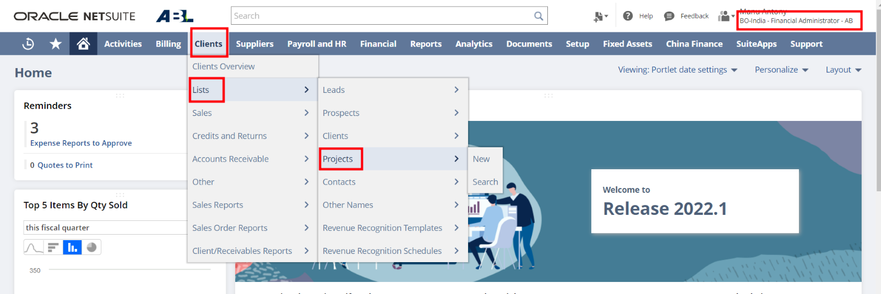In the financial administrator role, projects which has the same subsidiary of logged user is listing. From the list, select a project record, then you can see the button ‘**Resource Allocation**’.

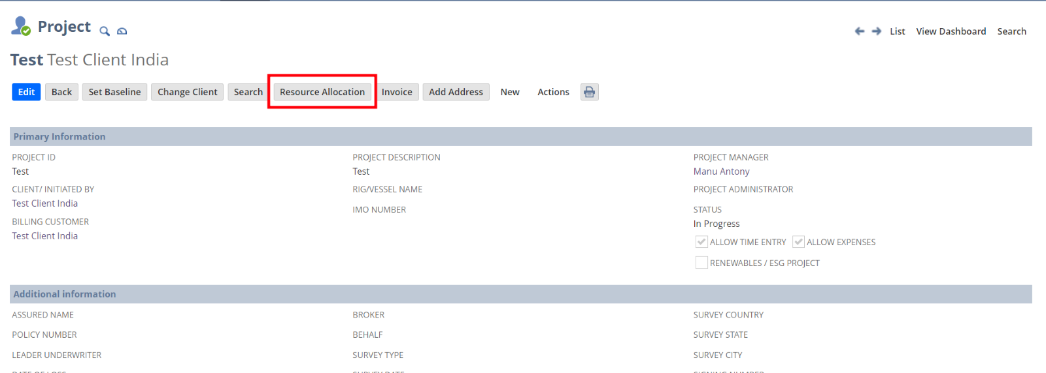  
By clicking the button, it leads to the suitelet page for that particular project task.

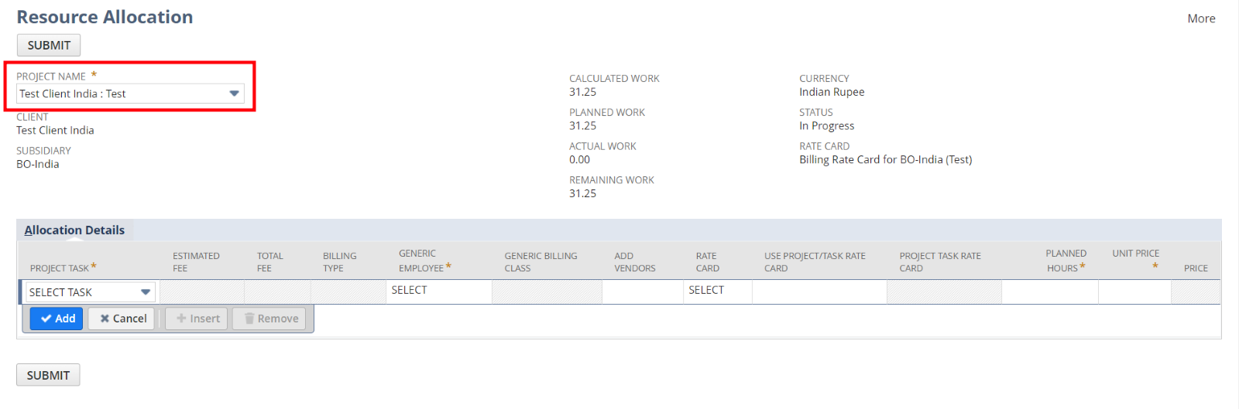In **Administrator** role, you can also access the process by the same method mentioned above. But in this role, this button will show only in those project, which is not inactive and it should be in Progress state and it should have a billing type and the logged user should be a project manager either in body level or line level.

**Scenario 1: Normal Working**

**1.** Select a project ( In financial administrator role, all project under the subsidiary of logged user’s role supports will be listed. In employee center role, projects in which the logged user is a line level/ body level project manager, will be listed and in Administrator role, all active projects which has InProgress status and billing type will be listed )

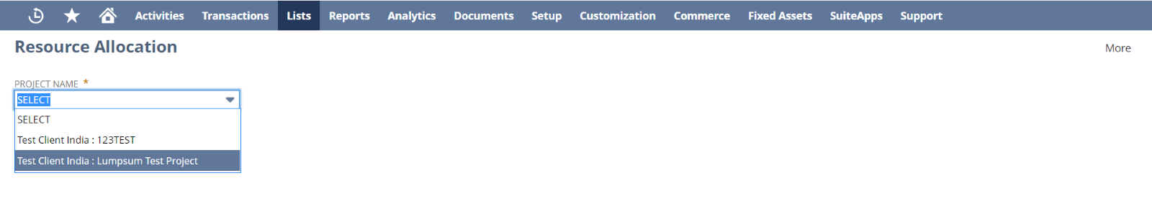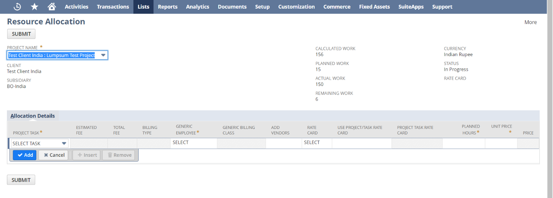

When you select a project, that project’s preference will change. In the preference tab, **’Display all resources for Project task assignment’**  checkbox will be automatically checked. This will automatically add the new resources in the project task to the project task record.

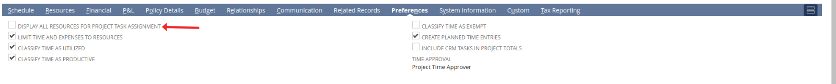check it’s resource list in the resource tab. This is the resource list before task allocation

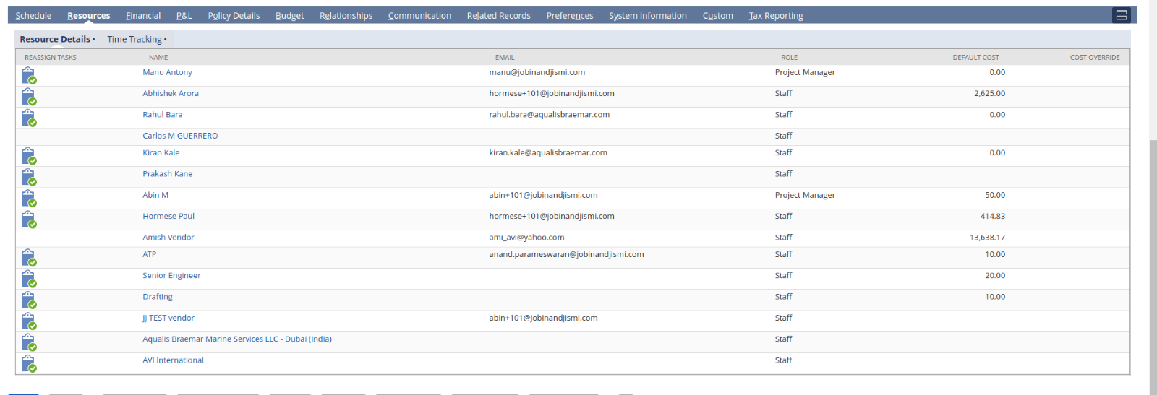**2.** Add a project task in the suitelet (Project task has certain criteria. Task should be in ’not Started’ or ’InProgress’ status and task shouldn’t be a milestone and it should have a billing type)

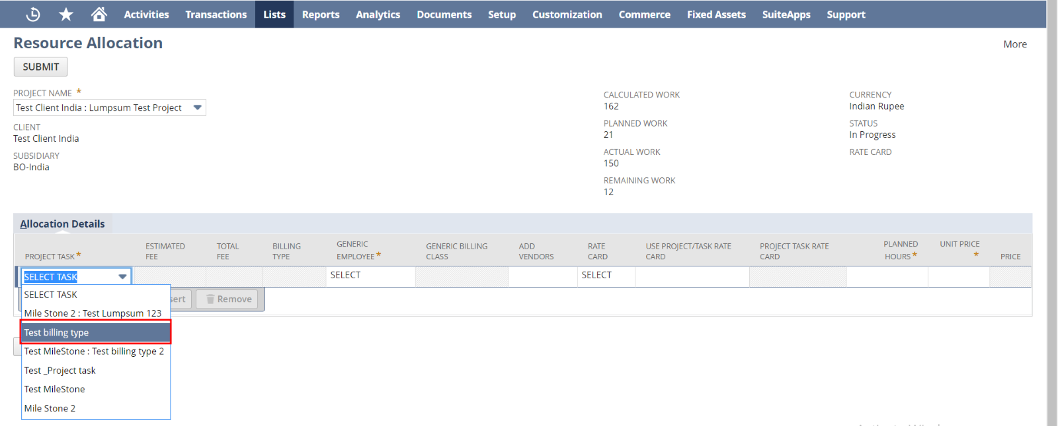By selecting a Project Task, It will automatically populate, the selected Project task’s Estimated fee, total fee and billing type.

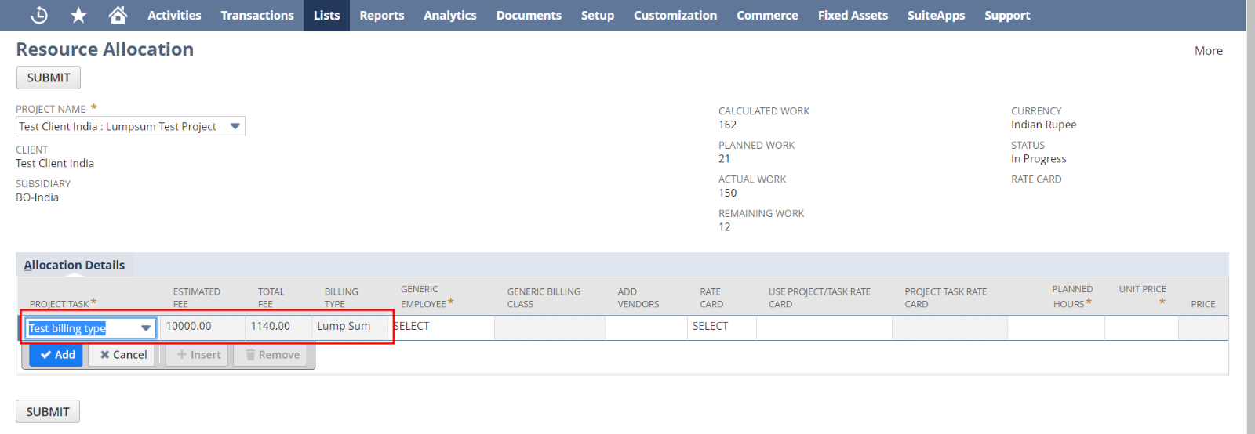**3.** You can select Billing Rate card both manually and automatically. If you want it automatically you can check the field **’USE PROJECT/TASK RATE CARD’.** If you want manually select any option from the drop down field **’RATE CARD’.**

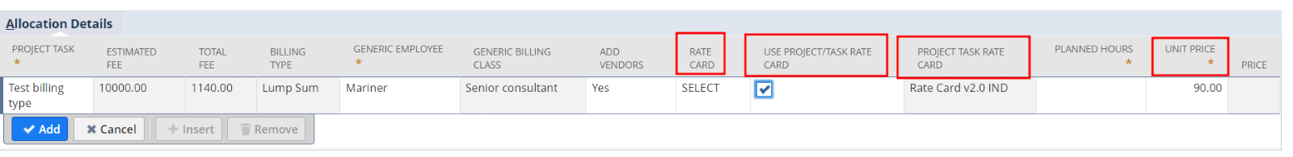When you select the rate card, then the selected rate card’s appropriate price will automatically populate in the **’Unit Price’** field. User can edit this value too.

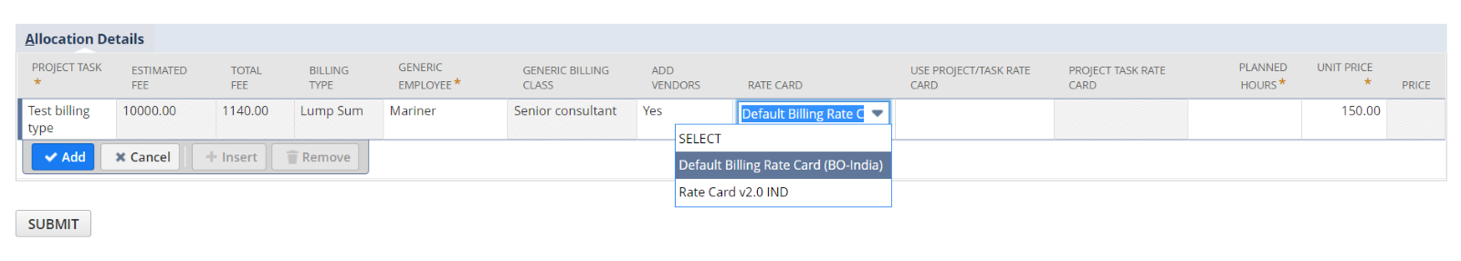

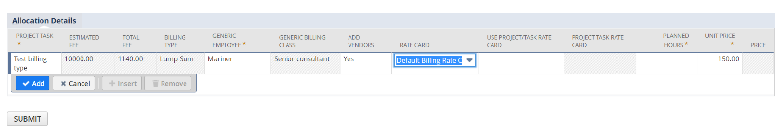If the user didn’t choose any billing card or if either the project task or project doesn’t have any billing rate card in their respective records, then there won’t be any rate card or unit price won’t populate in the page. In such situation the user can enter values.

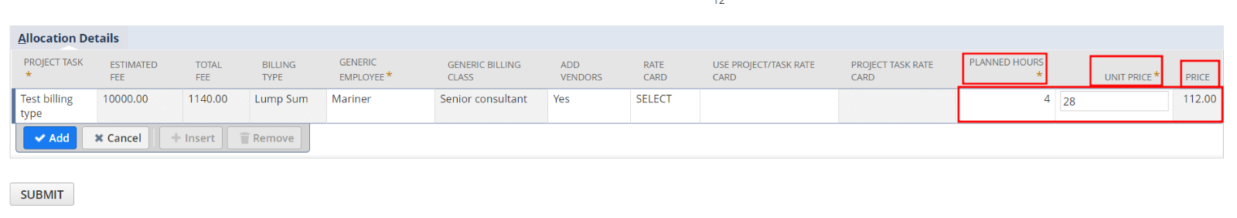

Billing Rate card in Project Task Record

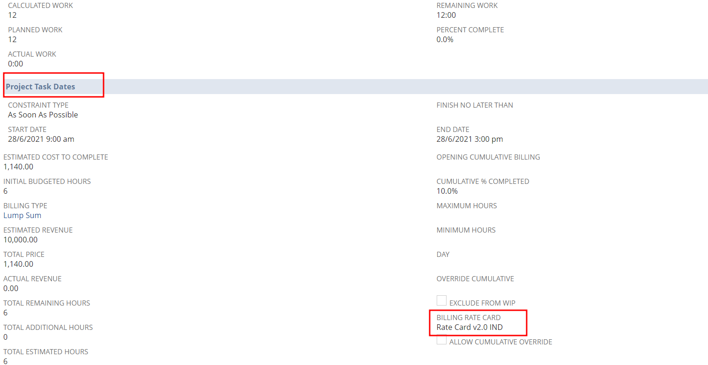

You can see Billing Rate Card in **’Custom’** subtab in a Project Record from the below image.

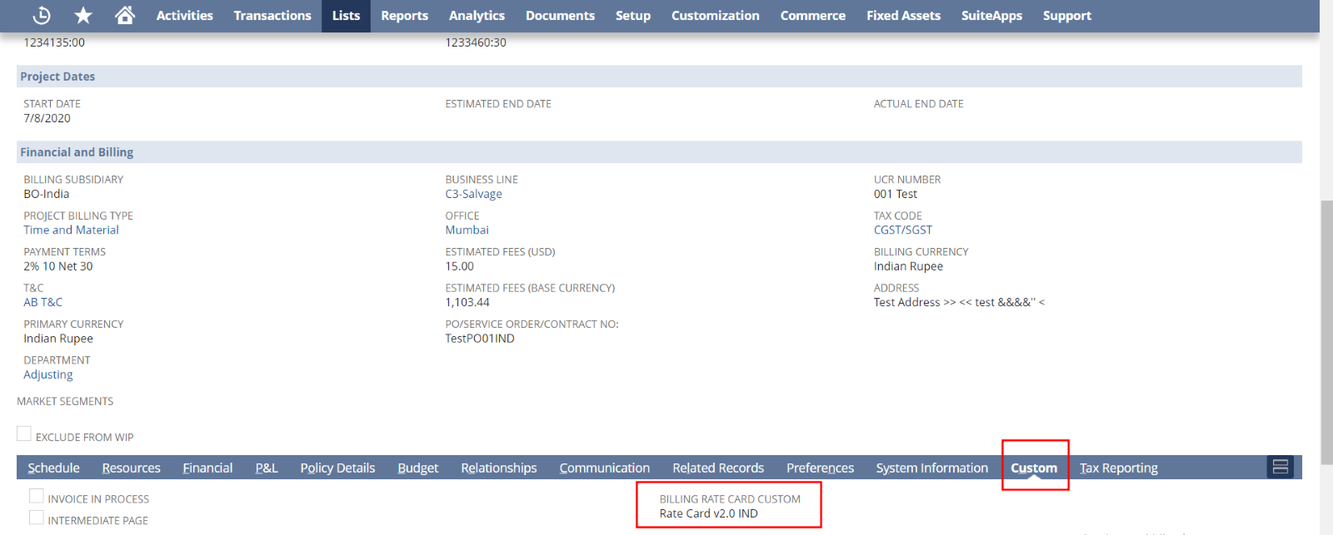**4.** Like that, you can also decide whether to allocate the task to vendors who has the same subsidiary of project and billing class of generic employee, or not. For that you can check the field **‘ADD VENDORS’**.

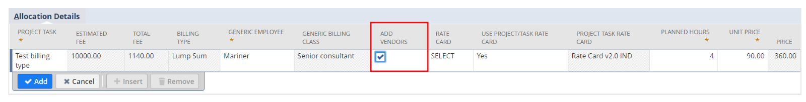

**5.** Open the particular project task record and check it’s assignee list before allocating the new resources.

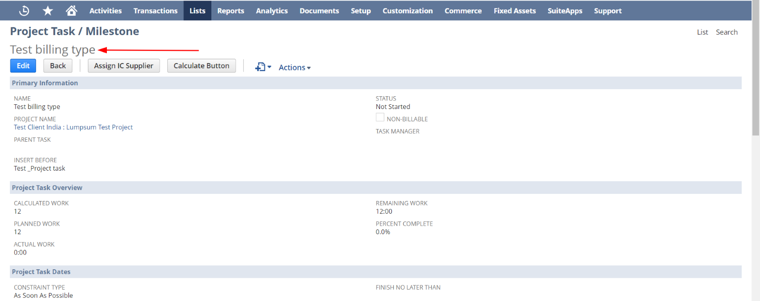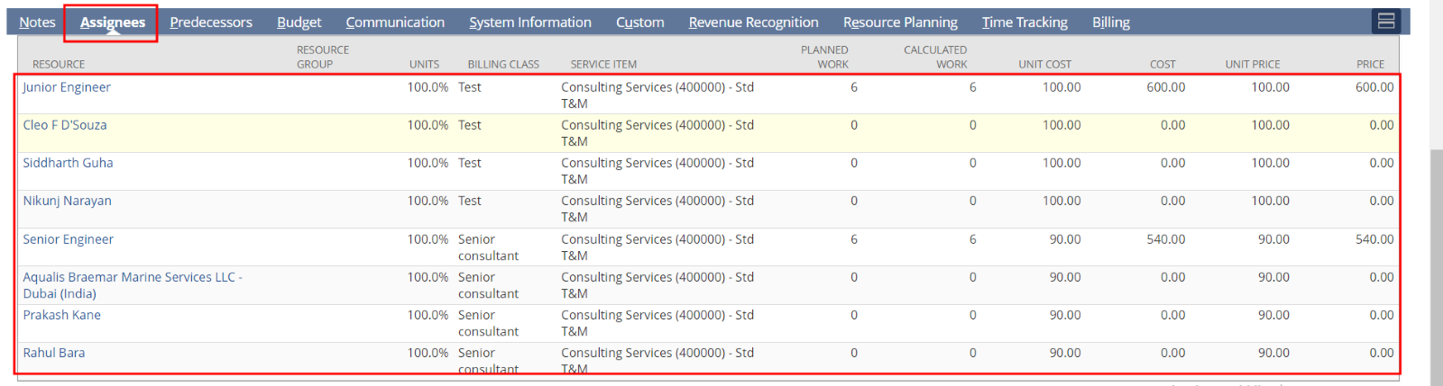**6.** Click add and click Submit. 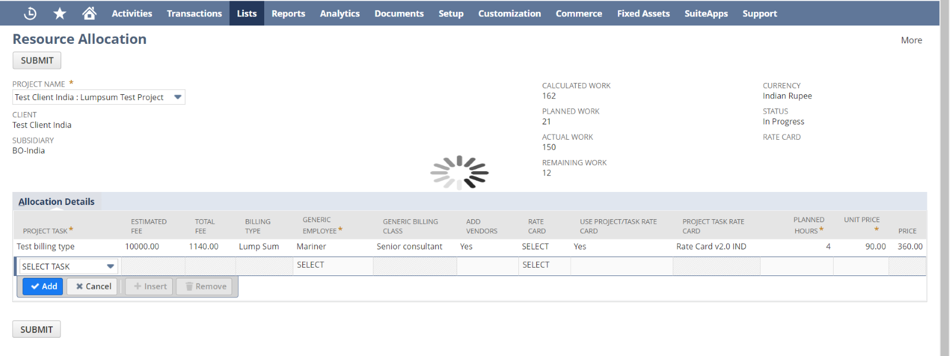If the process hasn’t any errors, then it will redirect to the first page

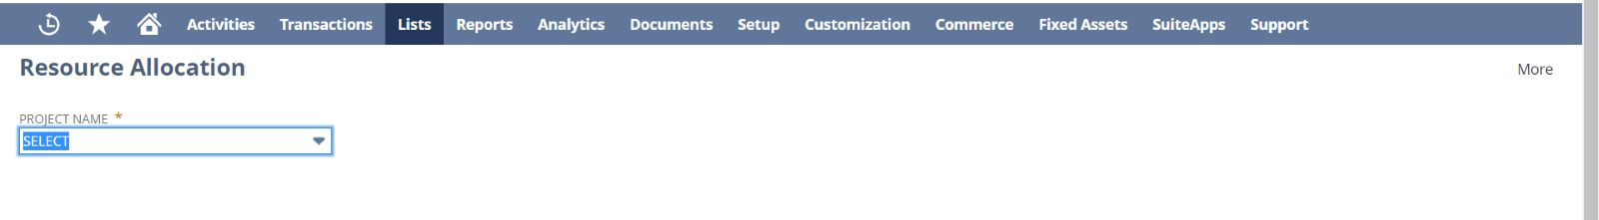Otherwise the error will show in the page as a warning

**7.** Then check the project task record to check whether new resources are added or not

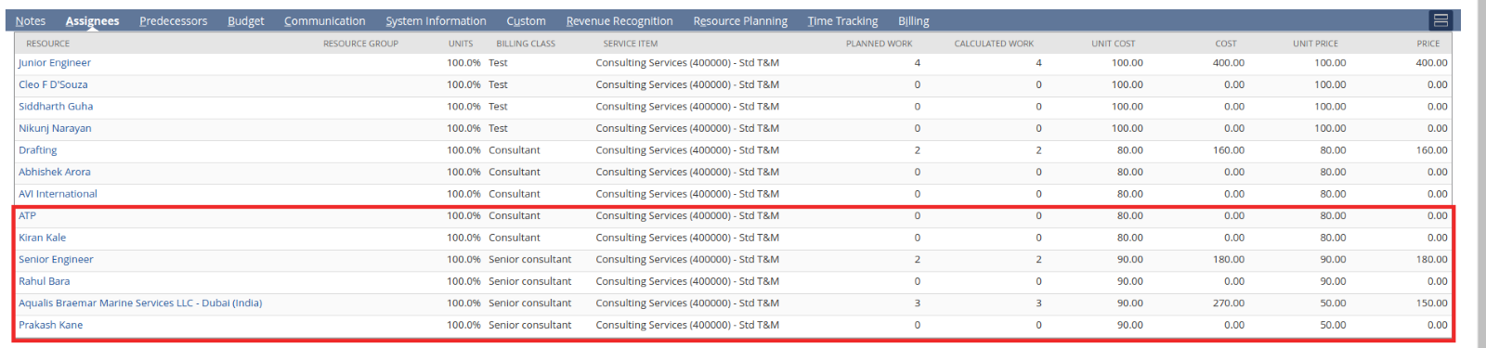In the assignees line, all the generic resource should only have the Planned hours and Unit Price. So Only they will have a total amount value. All other resources will have zero planning hours. Because of that, they will have a zero(0) total amount.

Likewise, when you check the **Unit Cost** field in the list, the value is populating from its corresponding assignee’s record. Ie; if the assignee is a generic Employee, the value will populate from **Labor Cost field.**

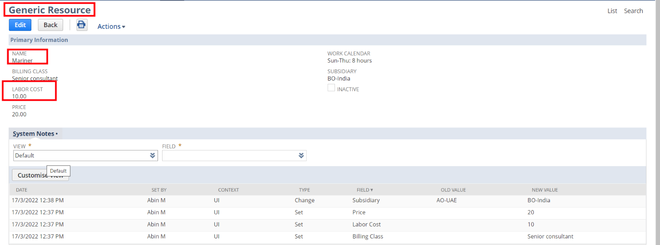If the assignee is an employee or Supplier, then the unit cost value is populating from **LABOR COST (EMPLOYEE/SUPPLIER SUBSIDIARY'S CURRENCY)** field.

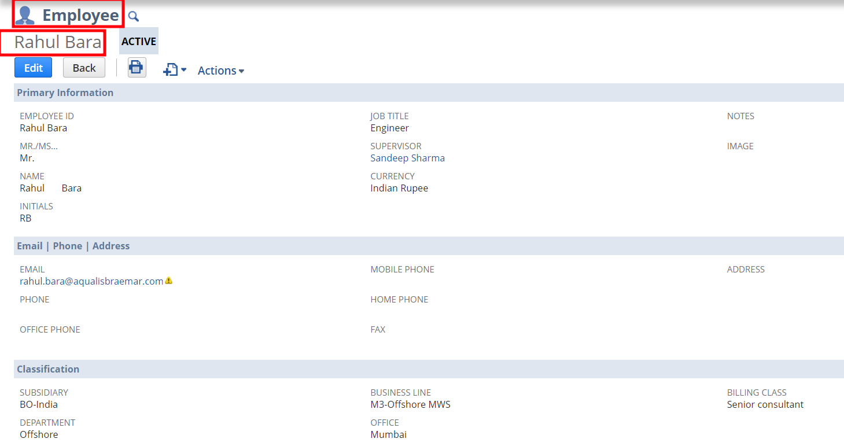

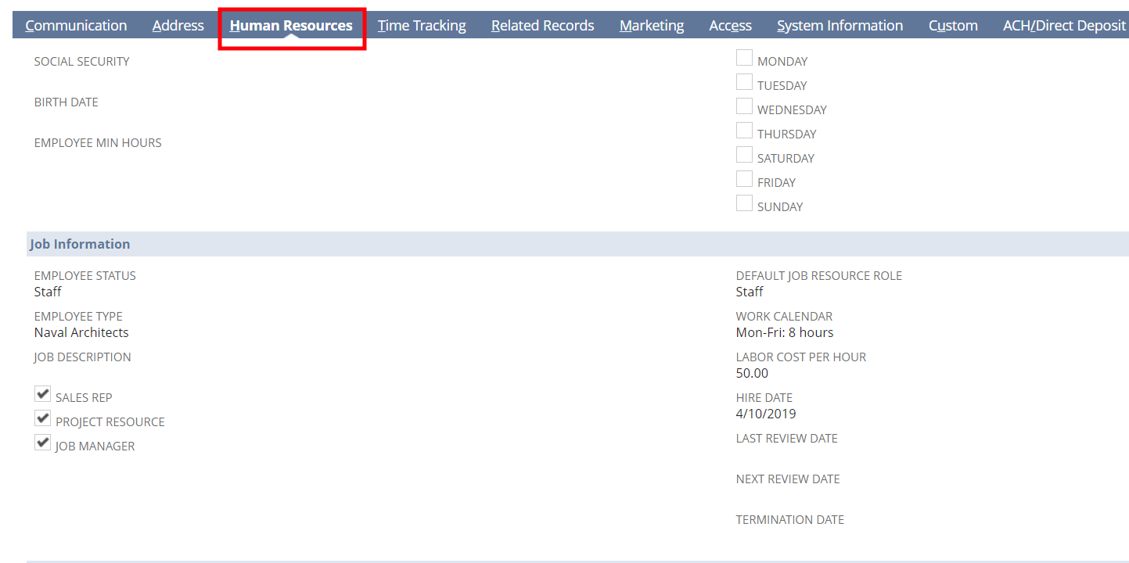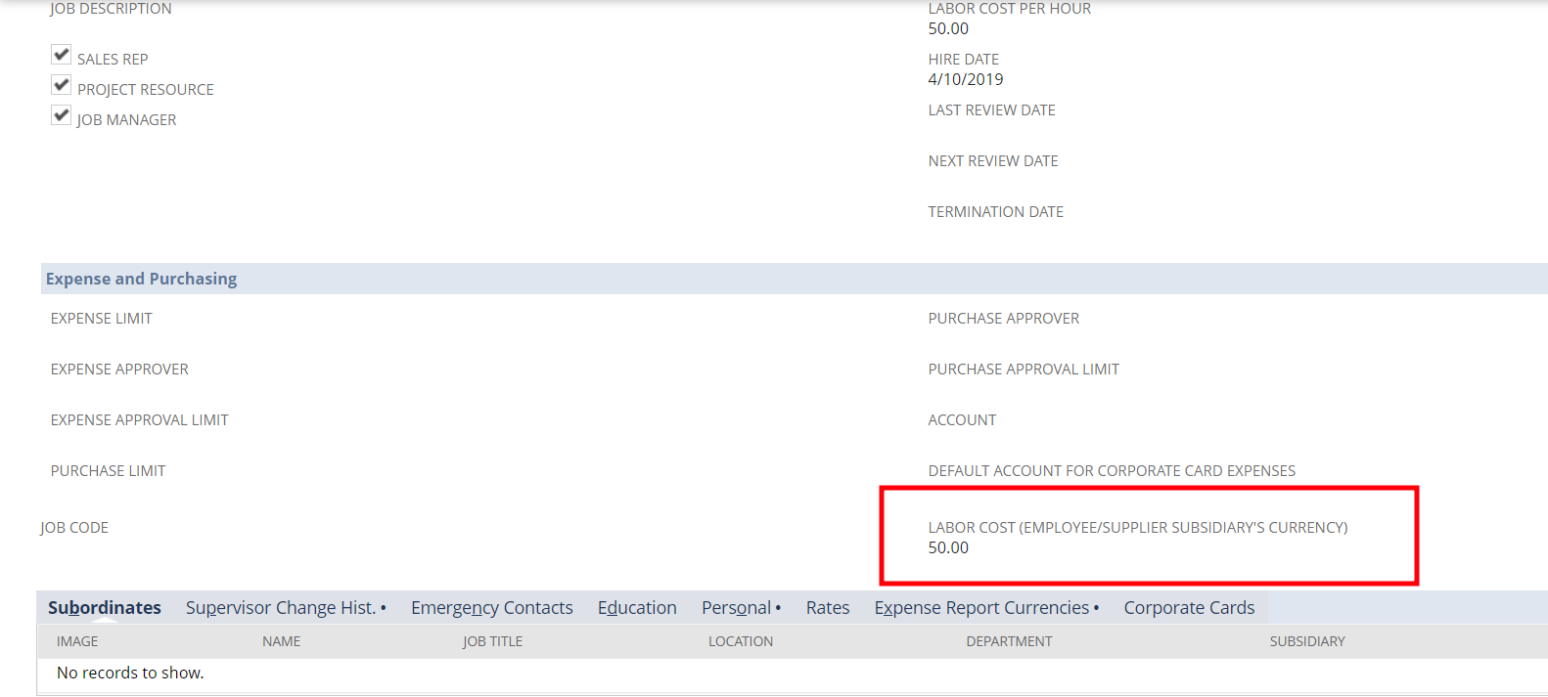

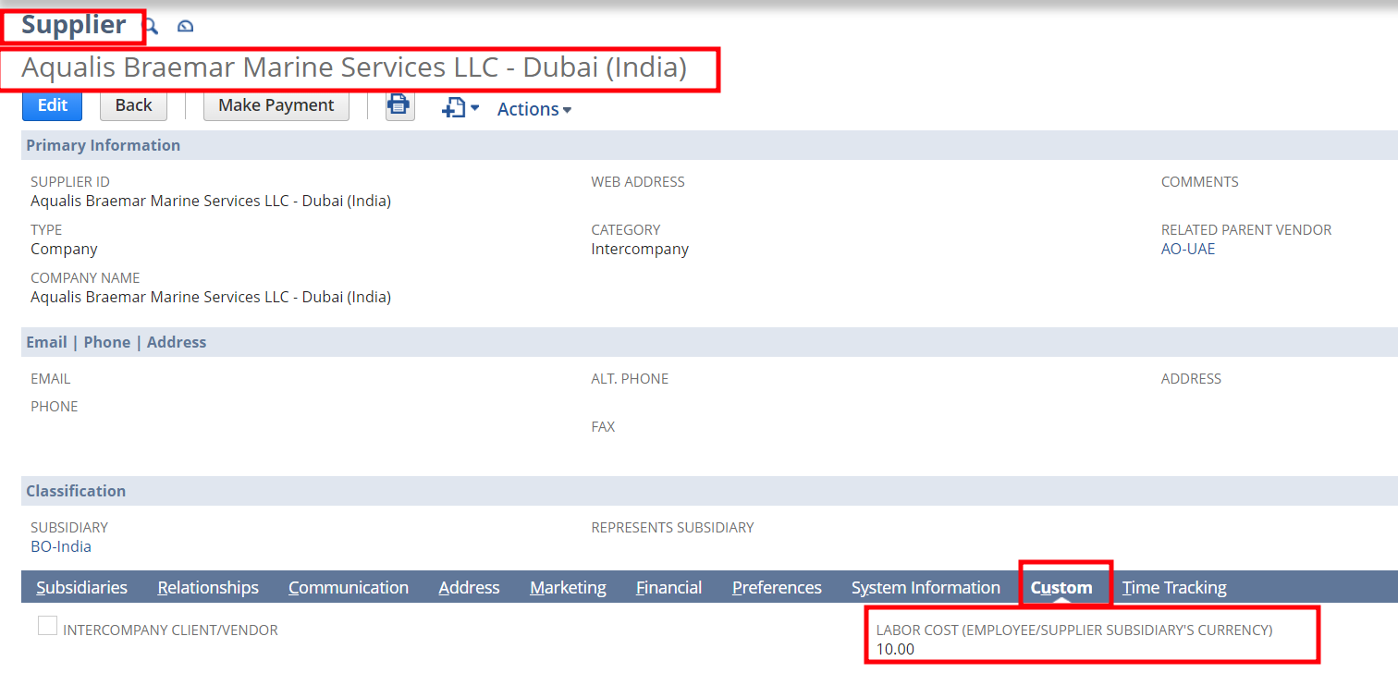

**8.** Check the project record also and check the resource tab. All the new resources who are in the project task will be in the project record also.

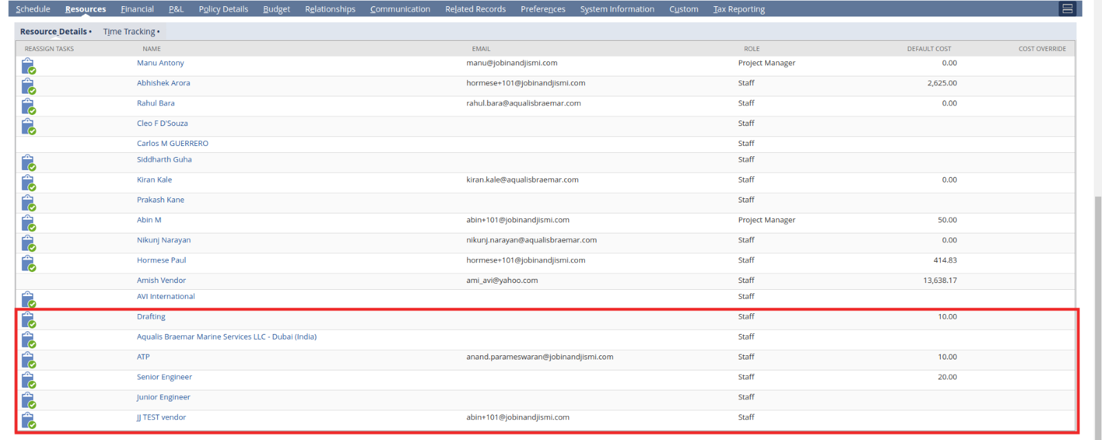**9.** Check the preference tab. The **’Display all resources for Project task assignment’** checkbox will be automatically unchecked



**Testing Steps Note: Normal scenario Testing is same for all other roles**

**Scenario 2: Validations**

1. Try to add an empty line

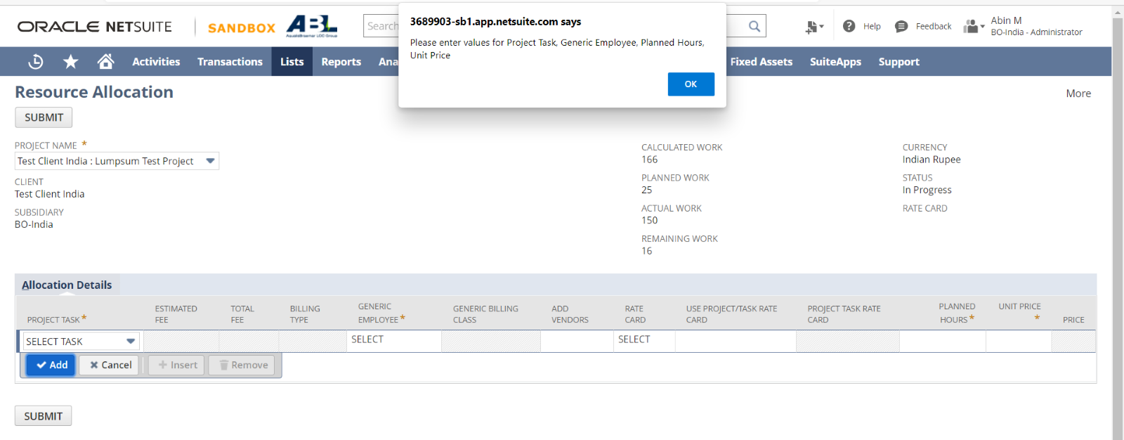

1. Try to Submit without adding a line

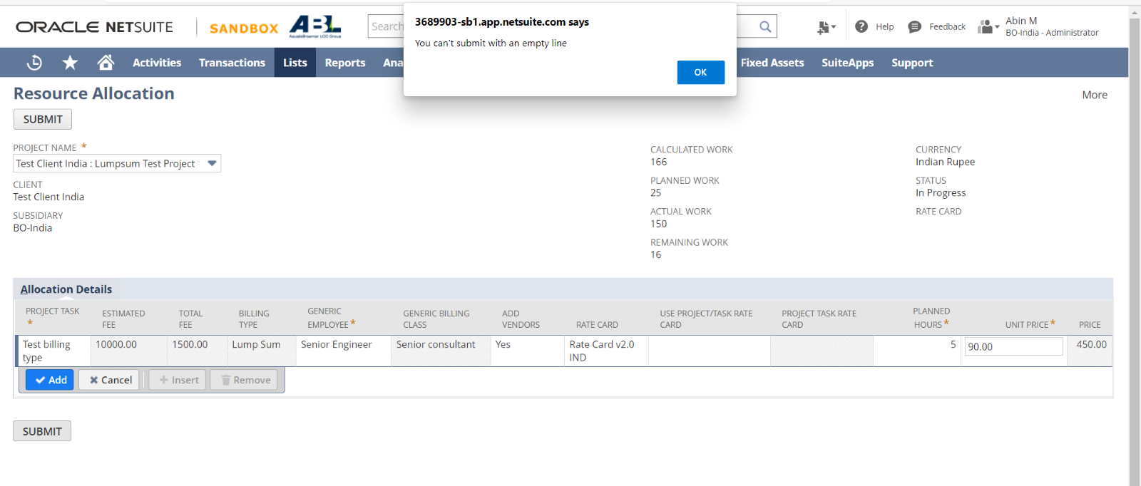

1. Try to add a line without giving any data/ mandatory data

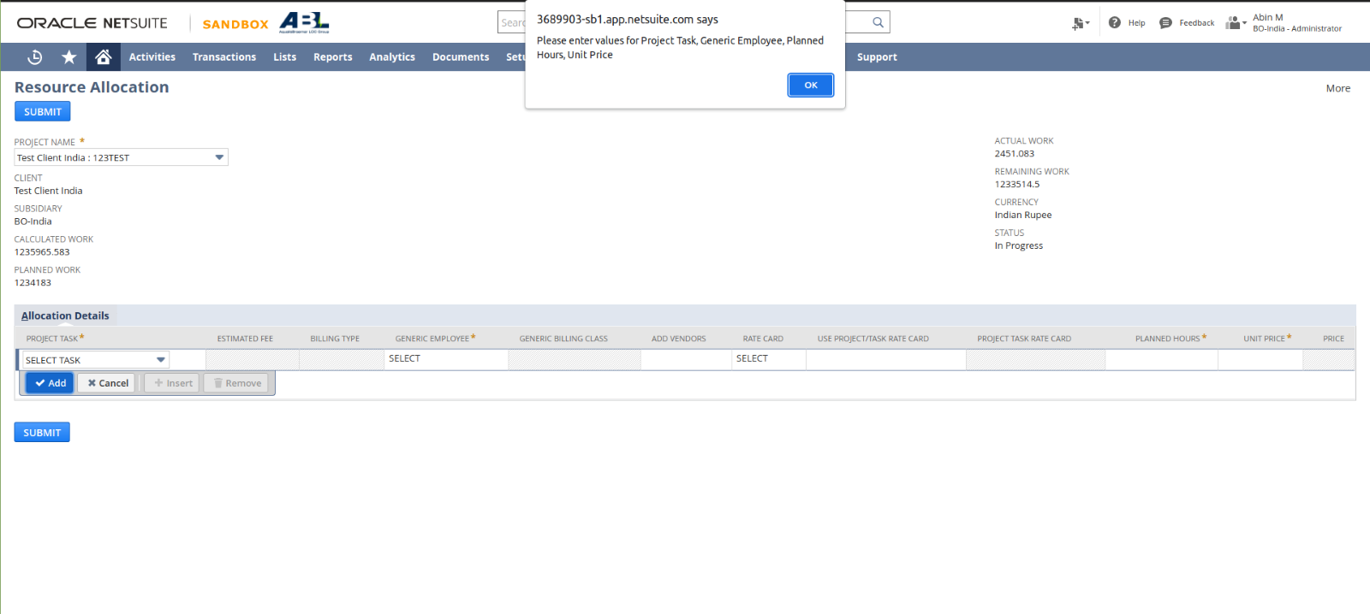

1. Select Rate card Manually and try to check the checkbox which is used for automatically select rate card

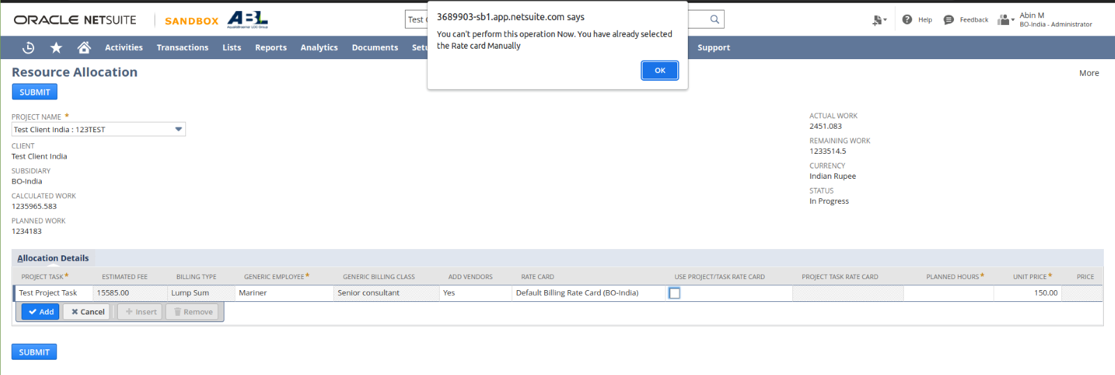

1. Check the checkbox for automatically selecting the rate card and then try to select rate card manually

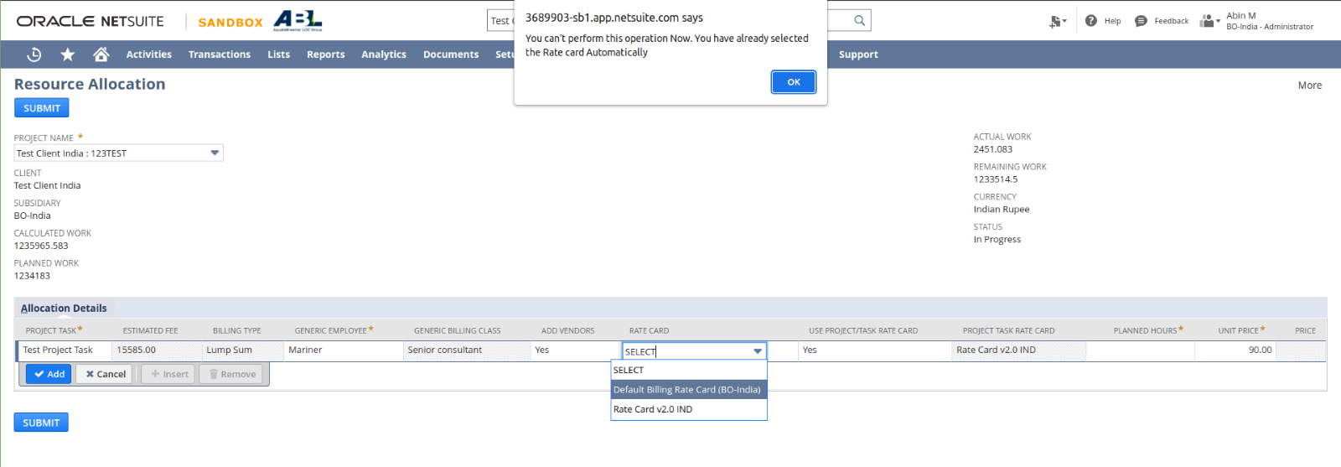

1. Try to Add line without giving values for planned hours

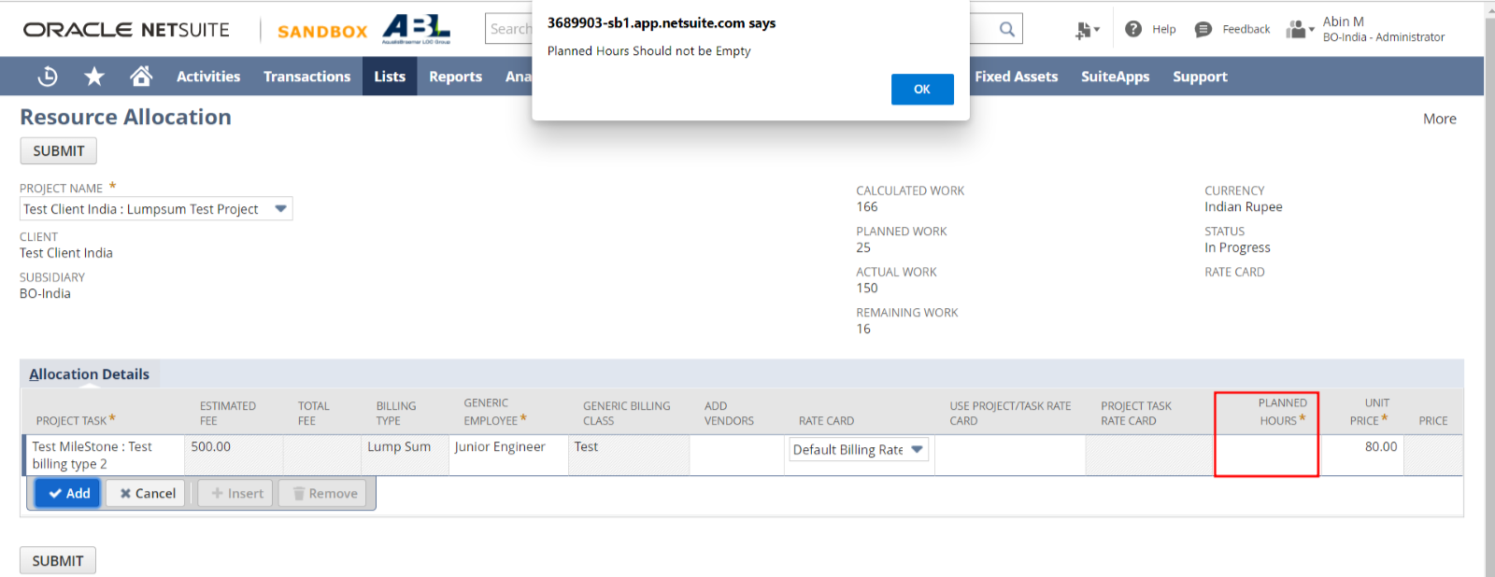

1. Try to Add line without giving values for Unit price

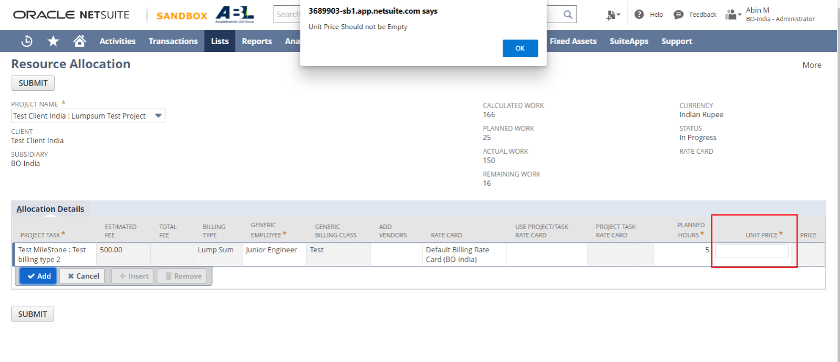

1. Try to add line by giving zero value to Planned Hours

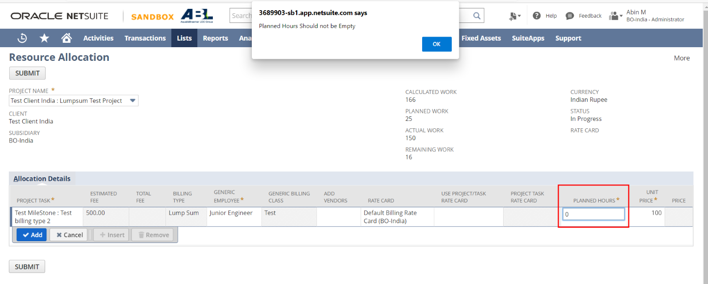

1. Try to add line by giving zero value to Unit Price

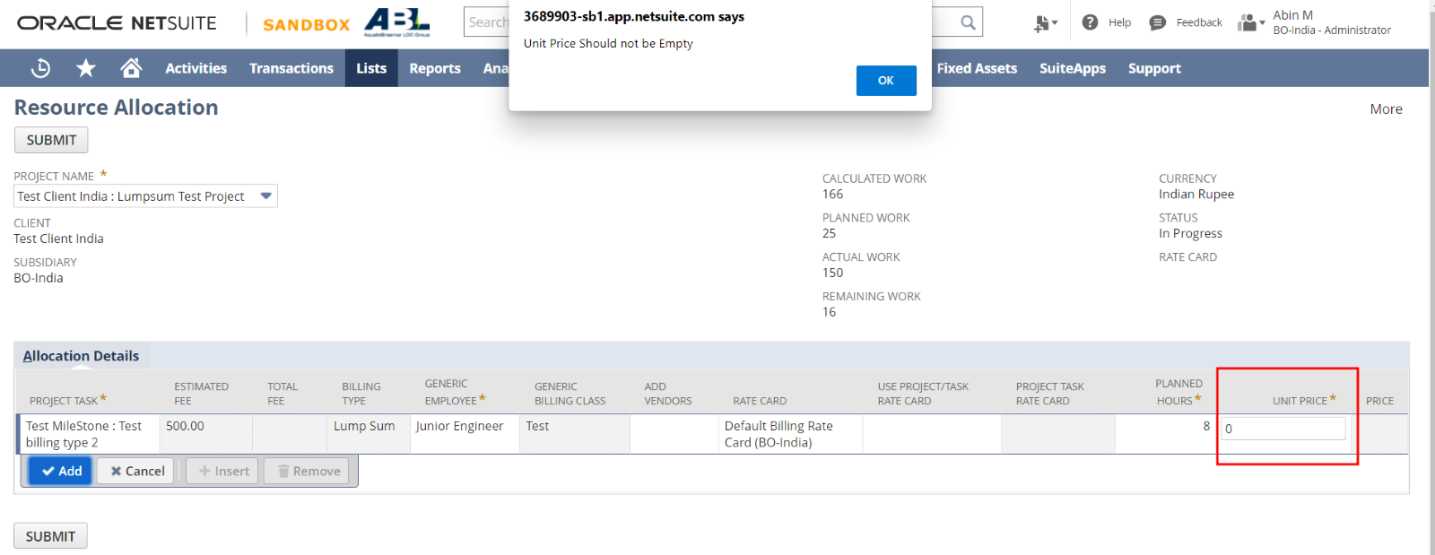

1. Try to Add line by giving Negative value to any field (same will be if both field’s values are negative)

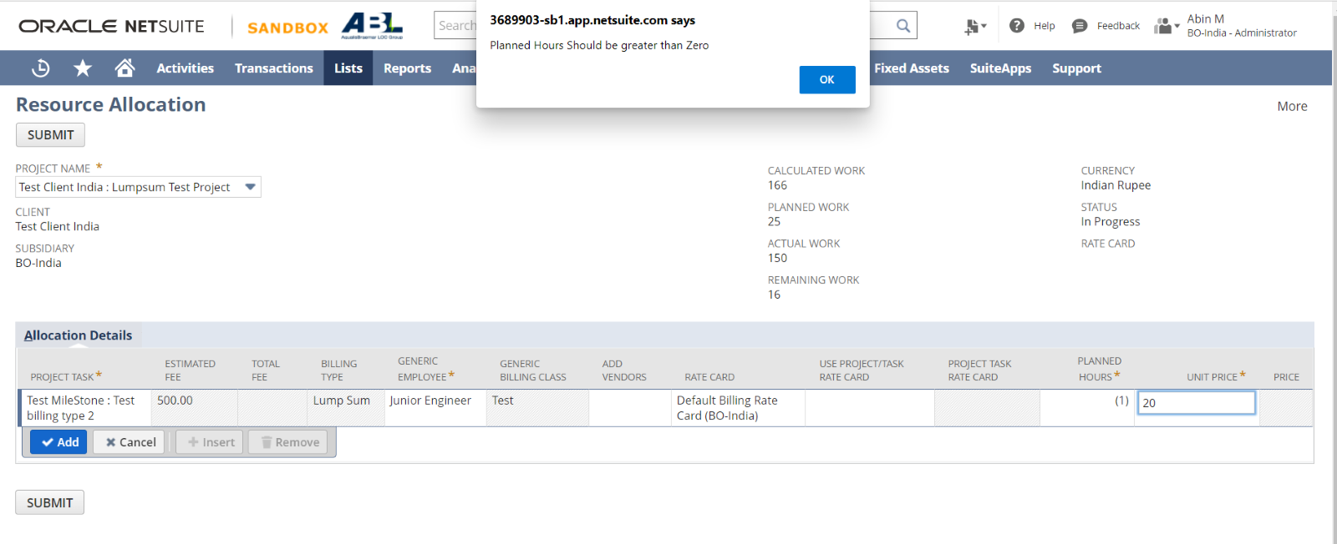

1. Try to add a line without giving Project task and all other values should be given

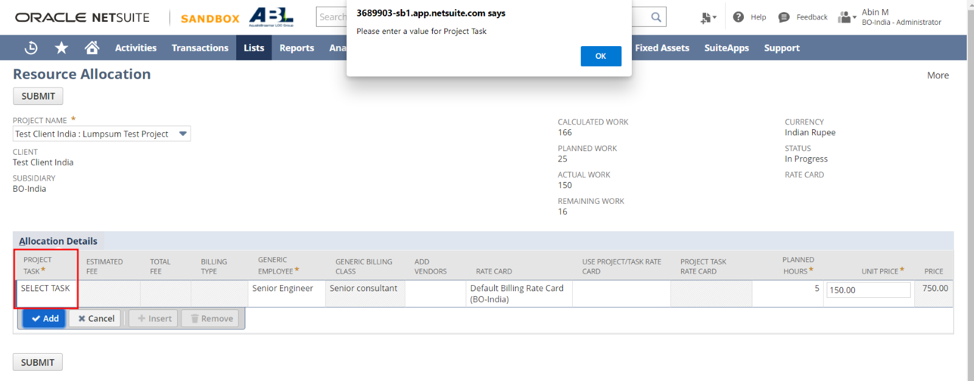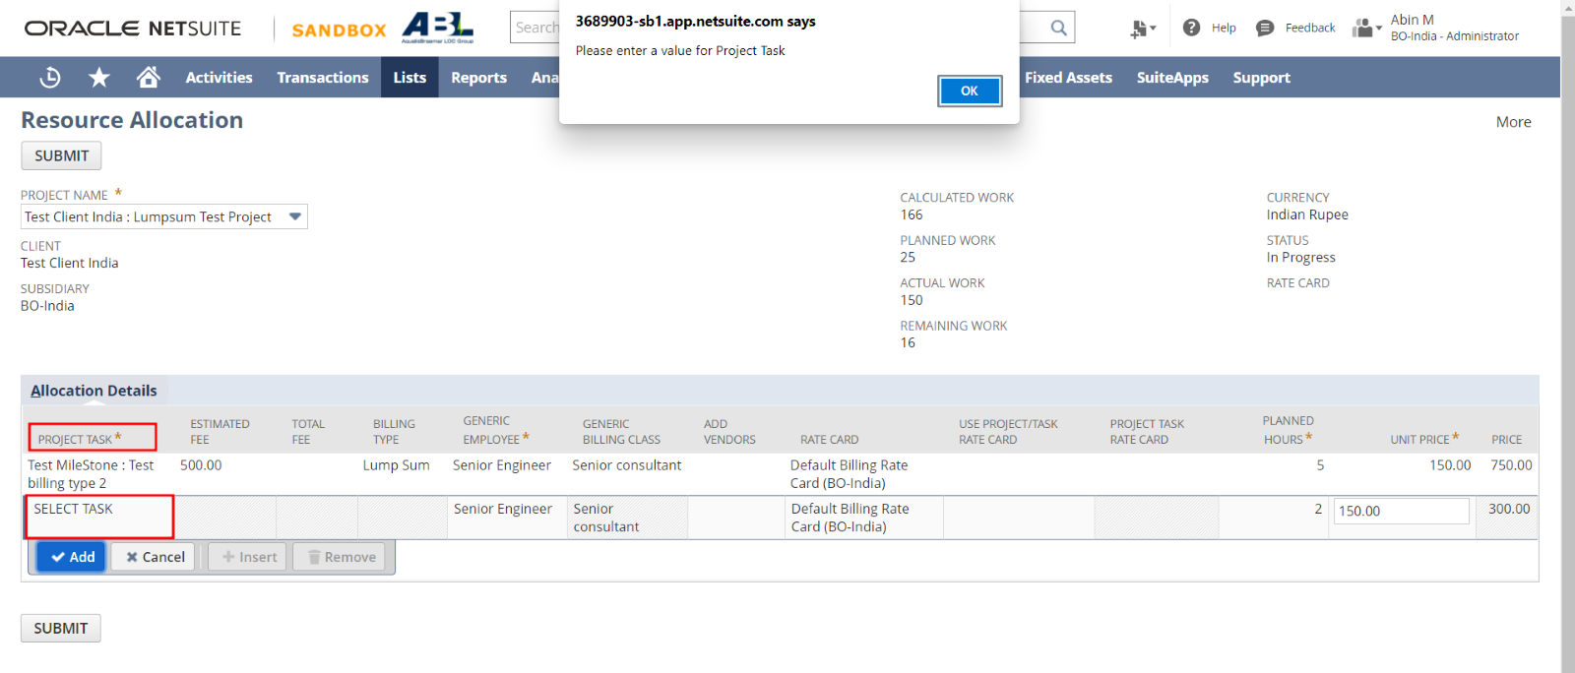

1. Each Project task should have an estimated fee and total fee (ie; price, that task is used). This Price should be less than or equal to the estimated fee. Otherwise an alert will pop up. After submitting the button, the script will check all lines and find the total unit price of each task and adds that with the existing total. Ie; existing total fee + User entered total price. This sum should also be lesser than the estimated fee of the selected project tasks. Otherwise an alert should be pop up

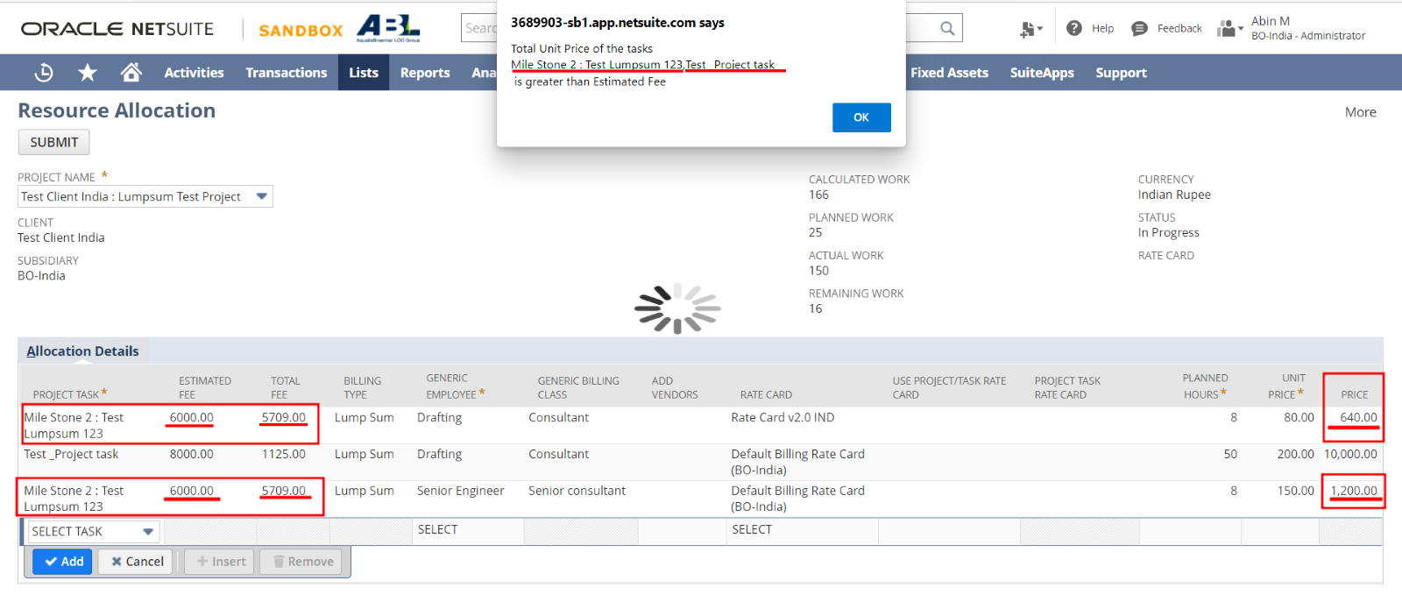

In the above image, you can see two task’s details. In the first task, it has an estimated fee 6000. And Its existing total fee is 5709. Now the user has given two more lines to the same task and not that particular task’s total Unit Price will be **5709+640+1200 = 7549,**  which is greater the estimated Fee of that task **(ie; 6000).** So, it has shown an alert. The loading symbol in the back ground will be hidden when you click the OK button on the alert

**Note:**

1. **If you add the resource who is already an assignee in the selected project task, that resource’s existing value will be saved without any changes. Ie; the newly added values won’t be added to the respective records. There won’t be any error alerts, the page will redirect to the first page like usual scenario. You need to check the change in the respective records.**
2. **The planned hours value which the user gives will be shown only in the line where the resource is an generic resource. All other resources, planned hours value will be zero.**

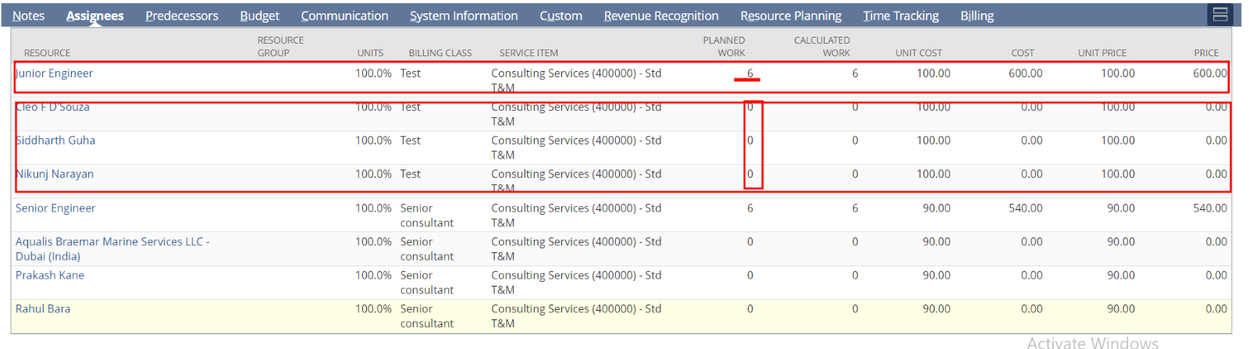**In the above image, the resource in the first line is a generic resource. So that line has planned hours value as user entered value. Other 3 resources below that line are either employees or vendors. So such resource’s planned hours value are zero. Service Item Value in the above image is static. (ie; the value won’t be changed)**

1. **Only committed lines will be saved.ie; the lines which has added first. If you try to save a line without adding it, that won’t be saved.**
2. **After selecting a Project, it will take a little more time sometime to execute. It is because it has some background process to be executed after selecting the option.**
3. **If the selected project task has a billing type ‘Lump Sum’, then only it checks whether the sum of total fee and sums of line level fees of a particular task is not exceeded the estimated fee.**
4. **Project shouldn’t have a department value ‘Admin’**
5. **For the production movement, this section need to add the following fields**
   1. **custevent3 – Project Billing Rate Card**
   2. **custrecord23 – subsidiary**
   3. **custentity3 - Billing Rate Card custom**
   4. **custentity_laborcost - LABOR COST (EMPLOYEE/SUPPLIER SUBSIDIARY'S CURRENCY)**